[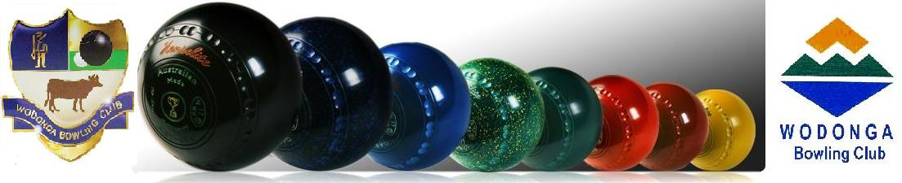](http://www.wodonga.bowls.com.au/site/index.cfm?fuseaction=display_main&OrgID=18224)

**WEBSITE – www.bowls.wodonga.com.au**

**ISSUE 1 – SEPTEMBER SEASON 2016-17**

**NEWSLETTER**

**FROM CHAIRMAN DAVID**

**WEBSITE – www.bowls.wodonga.com.au**



**CHAIRMAN DAVID’S REPORT**

***A warm welcome back to all members, particularly the grey nomads back from their time in the sun, and also welcome all our new members. Let us all set out to make 2016-17 a year to remember, firstly for fun and good fellowship, and then competitive individual and team success will surely follow.***

***After a long wet winter with washouts and low numbers seriously affecting revenue, we hopefully can now look forward to a great season of lawn bowls commencing with OPENING DAY and the HILDA HAWKINS MIXED PAIRS set down for the weekend of 11th September – with the event a challenging lead in to the Pennant season. SO WELCOME BACK EVERYONE!!***

PROPOSAL FOR A NEW PENNANT SHIRT FOR 2017-18 SEASON:

At the request of many members consideration will be given to designing a new Pennant Shirt with a little more flair for use in 12 months’ time, using the most up to date sweat resistant material available. The anticipated cost would be $40, but no decision has been made. A small committee is proposed to further investigate possible designs, and consult with a range of members.

HAVELOCK STREET:

This new road to be constructed over the next 8 months will extend from the Huon Hill Tavern to Osburn St., coming extremely close to Club property, (See Plan in Clubhouse), which has resulted in ongoing intensive negotiations with Council to have some protective fencing provided as part of the program budget. Initially promises were made, but in early reply correspondence they have not been honored, which is disappointing.

STATE GOVERNMENT SCHEME FOR “LED” LIGHTING:

After much chasing down of authorities administering this project, the Club was promised to have 109 x 1.2m fluorescent tubes replaced for a cost of $560 to be recouped in operational electricity costs within only a few months, which was tremendous news and complimented past decisions taken to lower energy consumption with solar installation, a renegotiated agreement with Origin Energy, and of course our new compressor. However, the project has “hit a snag” and until the scheme is renegotiated will not proceed. As many of you know dealing with a government department is not always straight forward. It is hoped that the delay won’t be for too long and the Club will soon achieve the benefit of these frustrating negotiations.

NEW SIGNAGE:

Improved signage promoting the club as a ‘FUNCTION CENTRE’ will soon appear on the Hovell Street entrance alcove and on the Clubhouse wall fronting the new Havelock St. This is being provided at no cost to the Club.

NEW MAJOR SPONSORS:

Cavalier Homes, Flight Centre and the SS&A Club have recently come on board in support of the Club, for which we are extremely grateful. Prompt payment of Membership fees and Sponsorship Renewals has been very helpful in assisting with cash flow over the winter.

VOLUNTEERS:

I must make mention of our band of workers who so generously give of their time to support YOUR CLUB, and the need for more members to give them some assistance. Straight back from holidays, Tony Smedley was on the mower making sure our surrounds remained presentable, gardeners Liz and Ralph Coulston and Dawn Fraser continue to toil away; with a “small group” diligently ensuring every Tuesday night Bingo successfully operates as an essential financial lifeline for our Club – Geoff Bath, Eddie Bullman and Mick McDermott are regulars, but an earnest request to other members to assist occasionally to ease the burden which often falls on too few. Last but not least is the wonderful band of ladies who are still catering for Wakes and the like, and particularly rose to the occasion in the off season to cater for 300 CFA personal, bringing over $4,000 into Club coffers.

MEMBERS HEALTH.

Various Club Members are doing it tough at the moment and we wish them all a speedy recovery, with early return to bowls.

**David**

**OFFICE BEARERS SEASON 2016-17**

**President Ladies:**

Joan Boyd

**Deputy President Ladies:**

Elaine Gilby

**President Men’s:**

Gary King

**Deputy President Men’s:**

Paul Davies

**Men’s Match Committee:**

Ashley Bates

David King

John Boyd

Brian Gilby

**Ladies’ Match Committee:**

Louise Farrar

Deanna Gardiner

Christa Broad

Isabel Pleming

Maxine Bounader

**Chairman:**

David Broad

**Director of Administration:**

John Gill

**Director of Finance:**

David Hillas

**“General” Directors:**

David Jackaman

Don Cameron

Gary King

Murray Lawn

**Mid-Week Selection Committee:**

Pat Jackaman

Pat Polly

Liz Coulston

Hellen Harrison

Dawn Fraser

**Weekend Selection Committee:**

Paul Davies

Chris Bird

Rick Gillman

Greg Porter

Gary King

**Delegates to O&M Bowls:**

Margo Howe

Gary King

PLAY BOWLS MONTH:

A recent Bowls Victoria survey revealed that over 60% of new bowlers started playing because of an invite from playing bowlers, and a further 15% started after being introduced the game by family.

With this in mind the Club has agreed with Bowls Victoria to be involved in a promotional program called Play Bowls Month with an aim to run Barefoot Bowls/ Jack Attack events every Thursday night in October and November, starting at 6.00pm and finishing by 8.00pm (we hope).

So members, please encourage other family members and any friends to come down to the club on a Thursday night in October or November during our Play Bowls Month.

Business House Bowls in November will still run but as a separate event to Play Bowls Month with the Club still requiring its core of volunteers to help.

However, the Club requires volunteers to assist in running the Barefoot Bowls/ Jack Attack events. The club already has a coordinator who will run the events, set the program, do the draws, speak on the mike etc., BUT NEEDS some helpers each night to show new bowlers (and possibly old bowlers) how to play the game and assist with the BBQ, etc.

A maximum of three people each night on a roster of twice over the eight weeks would require 12 members to volunteer.

IF YOU CAN HELP PLEASE CONTACT BOB ELLWOOD OR DAVID KING.

For more information, check out the Club’s website and also the Bowls Victoria website.

**FROM THE MATCH COMMITTEES:**

This month sees the start of the new bowls season so it’s time to dust off the bowl’s bag, give the bowls a bit of a polish and GET OUT ON THE GREEN.

Over the last few years participation in most club events has been down in numbers, so hopefully this year will see a large increase in entries.

Entry sheets for all Club and State events will be on the various notice boards around the Club well before the date of the event.

**LADIES STATE EVENTS**

89th OPENING DAY

**&**

**BORDER**

**CARPETS**

**HILDA HAWKINS**

**MIXED PAIRS**

**SUN. 11th SEPTEMBER**

**12:30pm**

**LADIES CLUB EVENTS**

Generation’s Ladies Fours Fri 16 September

Club Consistency Thu 22 September

Club Singles Thu 17 November

Club Mixed Pairs Sat 14 January

Club Pairs Fri 27 January

McHarg Ladies’ Medley Fri 24 February

Club Triples Thu 9 March

Ladies Invitation Triples Fri 7 April

**MEN’S CLUB EVENTS**

Club Triples Sun 18 September

Club Singles Sun 30 October

Club Pairs Sat 21 January

Australia Day Major/Minor Pairs Thu 26 January

60 & Over February Thu 2 February

Club Handicap Singles Sun 5 March

Dunstan Day Men’s Fours Mon 13 March

60 & Over March Thu 16 March

Hec Stuart - Winter Series Thu 4 May

**Close Date** **1st Day**

Novice Singles Wed 20 September Wed 27 September

Over 60 Singles Wed 28 September Tue 4 October

Over 60 Pairs Mon 10 October Mon 17 October

Pairs Thu 17 November Thu 24 November

Fours Mon 5 December Mon 12 December

Und 25 Singles Fri 9 December Sun 1 January

Triples Thu 5 January Thu 12 January

Mixed Pairs Fri 6 January Sun 15 January

Singles Sun 15 January Sun 22 January

**MEN’S STATE EVENTS**

**Close Date** **1st Day Play**

Pairs Fri 16 September Sun 25 September

Over 60’s Singles Fri 23 September Thu 29 September

Novice Singles Fri 30 September Sun 9 October

Over 60’s Pairs Fri 7 October Thu 13 October

Triples Fri 14 October Sun 23 October

Singles Fri 4 November Sun 13 November

Fours Fri 18 November Sun 27 November

Under 25 Singles Fri 9 December Sun 1 January

**SEPTEMBER DATES TO HIGHLIGHT IN YOUR DIARY:**

Thu 1 Hec Stuart Men’s Triples

Mon 5 Ladies’ Meeting

Sun 11 Opening Day / Hilda Hawkins Mixed Pairs

Fri 16 “GENERATIONS” Wodonga Ladies’ Fours

Sun 18 Men’s Club Triples Championship

Thu 22 Ladies’ Consistency Rnds 1 & 2

LADIES FOURS

FRI. 18th SETEMBER

10:00am

Sat 24 Men’s Club Triples Championship

Sun 25 Men’s State Pairs

Wed 27 Ladies’ State Novice Singles

Thu 29 Ladies’ Consistency Rnds 3 & 4

Thu 29 Men’s State Over 60 Singles

**MID-WEEK and WEEKEND SELECTION:**

To all Club members who are committing to another season of pennant we as your selection committees welcome you and hope that you all enjoy your time on the green and experience a very successful season.

The aim of both selection committees is to pick compatible rinks (as much as possible) and depending on availability, maintain stability in the rinks. Depending on numbers, we will aim to use a reserve list as much as possible to fill vacancies and avoid disruptions to a rink.

Some players may not be playing in their preferred positions, however, we expect every player to fulfil their commitment to the Club and strive to be the best you can in your given position. Any player not performing will be notified of the committee’s concerns prior to any action being taken. Any player moved to another position will be notified by a selector. Players need to be aware that unavailability may result in a return to a lower grade.

The selectors will be conducting skills/training sessions leading up to and during the course of the pennant season, with a view of improving our skills. Players will be notified of these sessions in due course by way of the website, newsletter or the noticeboard. Participation in these sessions is encouraged for all members.

Any player with issues will be invited to address their respective full committee. Committee members will also be in contact with each rink at some time after the game and prior to the next selection meeting. They will be asking one or two players and not necessarily the Skipper, a set number of questions to which we hope you, if contacted, will give a true and accurate response. This will hopefully give us a good idea how the teams are combining and identifying any flaws that may need altering.

We anticipate conducting a series of practice matches for all grades in the weeks leading up to the commencement of the pennant season. Again, we will be notifying players well in advance of dates and times via the webpage, newsletter and notice board.

While the Committee is pleased with the number of members who have already indicated they intend playing pennant this season more players are required to fill the teams and provide a “buffer’ of emergencies. All members who have paid their membership fees and haven’t yet indicated whether or not they intend to play pennant this season, will be contacted to gauge their intentions.

IF YOU DO INTEND TO PLAY PENNANT AND HAVEN’T INDICATED THIS TO THE SELECTORS  
 PLEASE ADD YOUR NAME TO THE LIST ON THE NOTICE BOARD

**PENNANT PRACTICE:**

The weekend selection committee has arranged to hold practice sessions/matches for weekend pennant players on Saturday 24th September at 1:00pm and Saturday 1st September at 10am. Saturday 1st is AFL Grand Final day and practice will be followed a barbeque and viewing of the Grand Final.

Practice sessions/games for mid-week pennant players are currently being finalized by mid-week selectors so please check the noticeboards inside the clubhouse and also the club’s website for details and dates.

RULE BOOKS:

Copies of *The Laws of the Sport of Bowls - Crystal Mark Third Edition*which cover rules for all bowling events across Australia are issued to all of our Club’s registered umpires. Members can also purchase copies direct from Bowls Victoria or arrange for our Director of Administration to purchase a copy on your behalf.

*The Laws of the Sport* are also available to purchase as an app for Apple devices such as iPhone and iPad (cost $4.49) and can be downloaded from the App Store on your device. In the App Store just type in Bowls Rules and download.

The other day my wife accused me of having

ALZHEIMERS.

“Not so”. I replied. “I have SOMETIMERS”.

“SOME TIMES I REMEMBER”.

“SOME TIMES I DON’T”.

**LADIES’ MEETINGS:**

In past years lady members met once a month with these meetings proving very popular, well attended and a great means of communication. The Ladies will again conduct similar meetings on the first Monday of the month with the first one being held on Monday 5th September.

**THE IMPORTANCE OF HYDRATION:**

Lawn bowls is the fifth most popular game in Australia and while not all bowlers are aged pensioners or broken down footballers generally participation is skewed towards older Australians.

Many issues of sports nutrition relate specifically to the elderly, but according to a study published a few years ago in the *Journal of Science in Medicine and Sport* lawn bowlers are in the highest category for serious environmental heat injuries, significant enough to result in admission to hospital with hydration deficiency topping the list for hospitalization.

Dehydration results from sweat, respiration (breathing), urine and skin water losses that are not replaced and decreases in cardiac output (the volume of blood pumped by the heart), skin blood flow and the production of sweat and accelerates the rise in body temperature with exercise in warm conditions

It is important that fluids are replaced during a game of bowls, but fluid replacement should never exceed the rate of fluid loss; you should not over drink.

A common mistake people often make when exercising in the heat is to drink only water. Water replaces fluid loss, but does nothing to replace electrolyte losses.

It is generally accepted by sport’s nutritionists that sodium loss from sweating can range from 1-5 of table salt during a game of bowls. Bowlers should replace this during a game by drinking a sport’s drink with sodium content of about 50-90mmol/L. But care should be taken not to overconsume salt because hypertension, a risk factor for heart disease, is a concern for many among the older population.

During prolonged games, drinking 100-250ml of a sports drink every 15-20 minutes should be enough to prevent heat-related injuries. Making sure the sport’s drink is cool and the taste is agreeable will greatly increase the chance of hydration.

Evidence suggests that a sport’s drink that provides 30-60g of carbohydrate an hour can delay mental fatigue, improve cognitive function, mood, motor skill performance and perceived exertion better than drinking the same amount of water.

Evidence also suggests that senior members of the bowling fraternity are most susceptible to heat illness because they do not maintain hydration during a game. Evidence also indicates that those older than 60 have: higher heart rates, a lower amount of blood pumped by the left ventricle of the heart in one contraction, and higher average skin and core body temperatures and lower sweat rates than younger adults.

Older adults can remain hydrated during normal conditions but our bowlers experience some of the hottest weather in the country in the peak of the bowling season and to avoid heat stress and or illness it is essential that bowlers of all ages, but particularly the more senior, are fully hydrated during all games.

**INDIVIDUAL AFFILIATION FEES – A THING OF THE PAST:**

Prior to the 2014/15 bowling season bowling clubs in Victoria had to pay Bowls Victoria an affiliation fee for every club member. In 2014/15 Bowls Victoria replaced the per-member model to a per-club fee.

In determining the required capitation fee Victorian Clubs were required to pay Bowls Victoria used as a base the total affiliation fees paid to them during the previous season (2013/14) plus 5%. The next season the fee was increased by another 5% and this season it was increased by another 2.5% which now brings our club capitation fee for our current season, 2016/17, to just under $12,000.

Bowls Victoria claim the main reason they introduced the new model was so clubs can better budget by knowing what capitation fee they will be required to pay for the season. They fail to mention that it is to Bowls Victoria advantage to know in advance, for budgeting purposes, the amount of income they will derive from club capitation fees.

Another non-published reason for the change of model is that it was thought that many clubs, although charging members an affiliation component in their membership fee, were not registering some of their members and retaining the affiliation component that should have been passed on to Bowls Victoria.

A consequence of this action by Bowls Victoria is that there is no longer an affiliation component in our membership fee for it is now the Club that is charged the capitation fee irrespective of the number of members. It also means that a person seeking dual membership cannot claim a fee discount on the grounds they paid affiliation at

another club.

**90th ANNIVERSARY OF WODONGA BOWLING CLUB:**

The 23rd of next month will be the 90th anniversary of the opening of the Wodonga Bowling Club almost exactly a year to the day after Club’s first Working Bee was held to develop four rinks which were later to become the basis for the now six rink Ellwood Green.

Previously approval had been given by the Wodonga Council for use of highest section of Council’s Hovell Street Reserve for the establishment of a bowling green at a nominal rent of one shilling per annum. Once this approval had been given inaugural members were enthusiastic and keen to get on with the construction of the greens.

Percy Lingford (first Club President and Shire Engineer) had prepared plans and levels and although only a four rink green was constructed an area sufficient for a six-rink green, a pavilion and conveniences and surrounding shrubbery was to be fenced off. The designated site was seen by many as ideal with the local newspaper *The Wodonga and Towong Sentinel* reporting:

*The soil is mostly sandy loam, which will greatly facilitate the drainage of the green. The distant hills and rustic scenery lend a soft, pleasing aspect, which, together with the fact that the main thoroughfare through the town is only a short distance off, makes the site most satisfactory for the purpose for which it has been set aside.*

Council was particularly supportive of the project expressing the view that a bowling green with surrounding shrubbery would present a more pleasing view to passing train travelers than an undeveloped waste area, which in turn would create a more favorable impression of the town of Wodonga in general.

But the project was not without its detractors and more than a few members of the community expressed the view that the venture was doomed to failure. Some were critical of the chosen site for the Hovell Street Reserve was always considered low lying with some parts frequently under water and was used in the main as a stock holding area. The site the Huon Hill Tavern now occupies was then a public sheep dip and sheep were often held on the reserve before dipping. Drovers would also hold sheep there overnight before loading them on trains for transport to Newmarket. Frequently cattle would also be held there before being taken to the Wodonga sale yards.

Despite the controversy surrounding the choice of the area set aside for the bowling club a group of enthusiastic members met on the morning of Saturday 17th October 1925 to begin the formation of the greens.

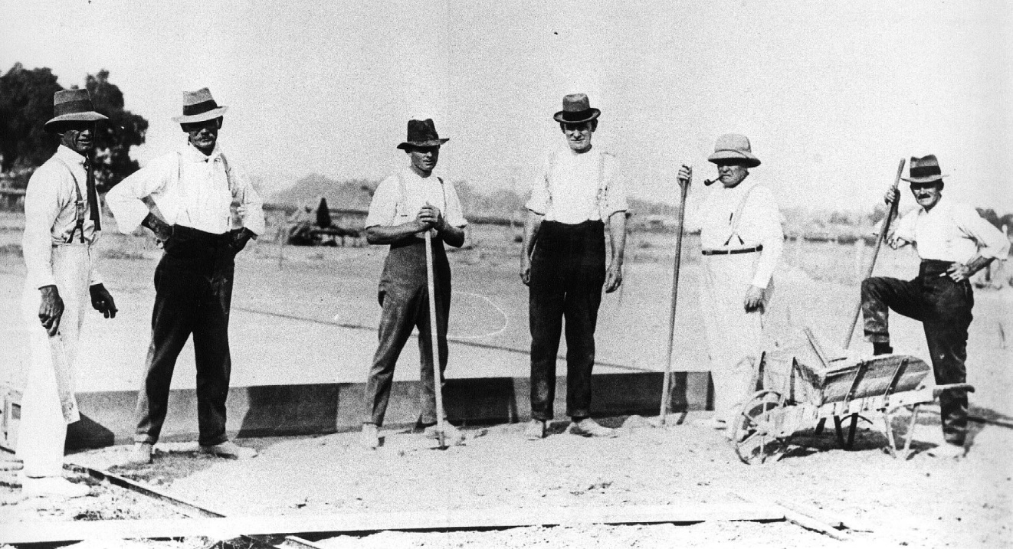Stan Condon is credited with turning the first sod having lent a single furrow plough for the task. Mick Martin lent two horses and also a man in charge. Alf Wilson brought along his double furrowed plough, three horses and a scoop. Vic Teese, Jim Flower, Arthur Beard and Eddie Owens assisted with Percy Lingford supervising. Mrs. Lingford, Mrs. R. Ryan and Jim Sealey (proprietor of the Carrier Arms) provided afternoon tea. By the end of the day all were delighted with the work accomplished.

**First day of**

**construction**

**of the First Green.**

**17th October**

**1925.**

**Left to Right:**

A.Wilson

Mick Martin

J. Street

Stan Condon

P. Lingford

F. Lambourne

**SEPTEMBER**

|  |  |  |  |  |  |  |
| --- | --- | --- | --- | --- | --- | --- |
| Mon | **Tues** | Wed | **Thurs** | **Fri** | **Sat** | **Sun** |
|  |  |  | **1**  Hec Stuart  Men’s Triples | **2**  Happy Hour  &  Raffles | **3**  Jackpot  Pairs | **4** |
| **5**  Ladies’  Meeting  Greens  Closed  Maintenance | **6**  Ladies’  Social | **7**  Men’s Social  Pairs 2x4x2 | **8** | **9**  Happy Hour  &  Raffles | **10**  Jackpot  Pairs | **11**  **OPENING**  **DAY**  Hilda Hawkins  Mixed  Pairs |
| **12**  Greens  Closed  Maintenance | **13**  Ladies’  Social | **14**  Men’s Social  Pairs 2x4x2 | **15** | **16**  **Generations**  Ladies’  Tournament  Happy Hour  &  Raffles | **17**  Jackpot  Pairs | **18**  Men’s  Triples  Championship |
| **19**  Greens  Closed  Maintenance | **20**  Ladies’  Social | **21**  Men’s Social  Pairs 2x4x2 | **22**  Ladies’ Consistency  Rnds 1 & 2 | **23**  Happy Hour  &  Raffles | **24**  Men’s  Triples  Championship  Jackpot  Pairs | **25** |
| **26**  Greens  Closed  Maintenance | **27**  Ladies’ Social | **28**  Men’s Social  Pairs 2x4x2 | **29**  Ladies’ Consistency  Rnds 3 & 4 | **30**  Happy Hour  &  Raffles |  |  |