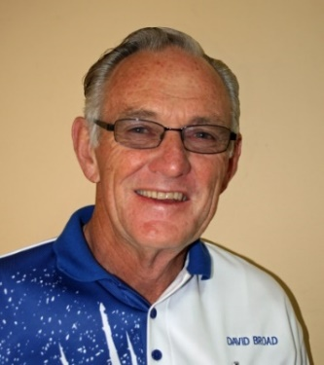
CLUB WEBSITE – www.bowls.wodonga.com.au
ISSUE 2 – OCTOBER SEASON 2016-17

NEWSLETTER
LED LIGHTING:
CHAIRMAN DAVID’S REPORT:
As previously advised the signed proposal accepted by the Club for 109 x 1.2m fluorescent tubes to be replaced under the “Vic Energy Efficiency Target” program at a cost of $560 had “hit a snag” and looked doubtful to proceed as the quote apparently had to be fully revised. The electrician involved had also severed all ties with the company involved – “The Green Guys Group”. But after constant representation a very reasonable outcome has been achieved, with all tubes now to be replaced at a revised cost of $728, which will very soon be recovered in reduced operational costs.

NEW FUNCTION CENTRE SIGNAGE:
This signage is now in place and should greatly improve our exposure to the wider community, that the Bowling Clubhouse is much more than just a refuge for registered club members, and is always available for private hire, providing essential external income for the Club’s survival. It is again pointed out that this is being provided at no cost to the Wodonga Bowling Club.

COME and TRY BOWLS - BAREFOOT BOWLS - CHRISTMAS RAFFLE:
These events to both attract new members and provide extra revenue for the Club, like our weekly Bingo, do not just happen, they require a great deal of input and assistance from members, if they are to be successful and keep Membership and Green Fees at modest levels. This is especially the case in 2016 because of the substantial loss of revenue due to wet weather and the abandonment of many days of Winter bowls. Please offer you help in the conduct of the above events/tasks, and not leave it to too few, or the future of our Club will indeed be bleak.

HAVELOCK STREET ROAD CONSTRUCTION:
After meeting more than 5 weeks ago with City of Wodonga’s Project Engineer and a representative from Vic Track, from whom the Bowling Club has historically leased land to be absorbed as part of the new road construction, a response has been received regarding our request for protective fencing of our greens.

Council state they will evaluate our quotes for fencing “in due course” along with our request for further consideration regarding council’s contribution to the cost of these works further stating, “Once we have determined a way forward, we will make further contact. This is anticipated within the next four or five weeks.” Not very encouraging!

Council then go on to say, “please be assured that despite your expressed concerns, this council recognises the important role played by Wodonga Bowling Club, the sense of place it creates and the social hub it provides and undertakes to work collaboratively with the club in the best interest of the city.” We will wait and see!
David.

RELOCATION OF TREES:
Three ornamental pear trees that would have been in path of the Havelock Street extension have been relocated to the lawn area in front of the main carpark. It is hoped they will prosper in their new position. Wooden stakes are now in place indicating the path of the Havelock Street extension which will give members some idea how close the new road will be to the Club.
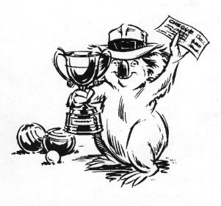
WINNERS ARE GRINNERS:
Congratulations to:
Julie and Bernie Jones.
Winners of the Hilda Hawkins/Opening Day Pairs.
Elaine Gilby, Jean Barber, Lea Taylor and Wendy Kelly.
OPENING DAY – HILDA HAWKINS:
Fifty-two bowlers took part in the popular Hilda Hawkins Mixed Pairs sponsored by WODONGA BORDER CARPETS on Sunday 11th September with this event doubling as Opening Day for the 2016-17 season.
Three games of ten ends were played and although some bowlers were a bit rusty after the winter “lay-off” in general the bowling was of a high standard. Results of play were as follows;
1st Prize – Julie and Bernie Jones, 3 wins plus 40 shots up,
2nd Prize – Eva Reuss and Paul Smythe, 3 wins plus 20 shots up.
Best 3rd game winner – Margot Howe and Rick Gillman, 16 shots up.
AIRMAN DAVID’S
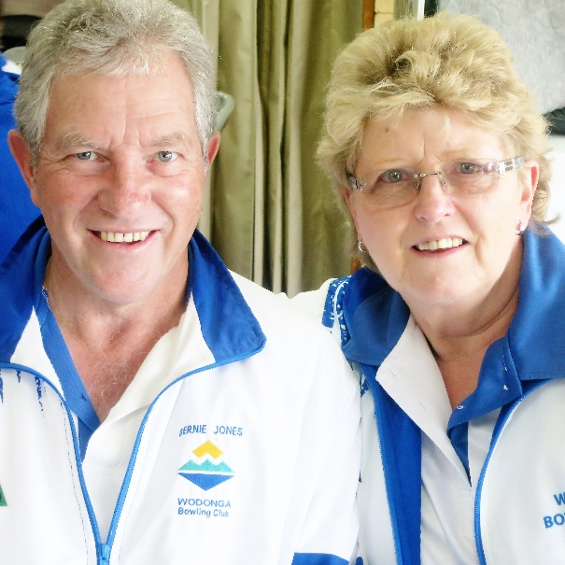
Winners of the GENERATIONS Women’s Fours.
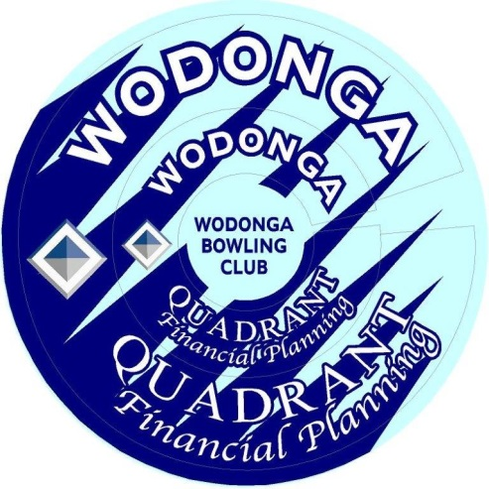
BOWL’S RINGS:
The Club is extremely appreciative of Stephen Coulston’s support through his firm QUADRANT FINANCIAL PLANNING who has once again sponsored the purchase of the bowling rings to be used by members this season.

As we all know our Club could not survive without sponsors so it is important all members support the firms who support our Club.

Stephen, with his easy going approachable demeanor would be more than happy to provide advice in a very relaxed manner on any financial or investment concerns members may have.

FROM the WEEKEND SELECTION COMMITTEE:
The 2016/17 weekend pennant season is getting underway on the 22nd October and we wish all players who have indicated their commitment to playing weekend pennant all the best for the season and we hope it is another successful season for the Wodonga Bowling Club.
Welcome to the new members who have availed themselves to weekend pennant for the mighty 'Bulldogs', enjoy your season.
There have been some members who have left the club or are not available to play weekend pennant this season for various reasons. As a result, there are a number of positions up for grabs for example in the first week of pennant there will be six positions vacant, this situation will filter through all the grades. Our message to players is simple, if your desire is to play at a higher level then practice hard and with purpose.
There are a number of club coaches at Wodonga we strongly recommend that you seek out one of the coaches if you are having a problem with your delivery or shots that you want to play, from playing as a lead through to a skip.
Just a reminder for the players who have put their names on the Reserve/Emergency list for weekend pennant, you are required to put your name on the 'Unavailable List', otherwise the selectors will assume you are available for selection.
Last Saturday the 24th September pennant practice/trial games were held with a healthy number of participants. It is on again this Saturday the 1st October (AFL Grand Final day) starting at 10am until about 12.30pm, if you are available please put your name on the sheet which is inside the club.
We would ask all players to read the selection committees policy and also the clubs 'Code of Conduct'. The selectors are 'volunteers' just like other committee/board members we are doing the best we can for the WODONGA BOWLING CLUB.
The club is having a pennant players get together on Thursday the 20th October starting at 5.30pm. There will be some food available. We would like to see all pennant players attend please.
Pennant players you need to have the new club rings on your bowls prior to the first game. Rings will be distributed to all pennant players at the Club pennant practice sessions.
REMEMBER YOU ARE PLAYING PENNANT FOR THE WODONGA BOWLING CLUB AND FOR YOUR TEAM.....IT IS A TEAM AND CLUB GAME….BE A PART OF YOUR TEAM..... THAT MEANS PLAYING IN THE POSITION AND TEAM YOU ARE SELECTED IN.
Have a great start to the season.
Chris, Greg, Gary, Rick and Paul.
Weekend Pennant Selectors

WORKING BEE – 9AM to 11AM on Monday the 17th October.
This is a continuation of last year’s idea – a bit of valuable work and then coffee & chat.

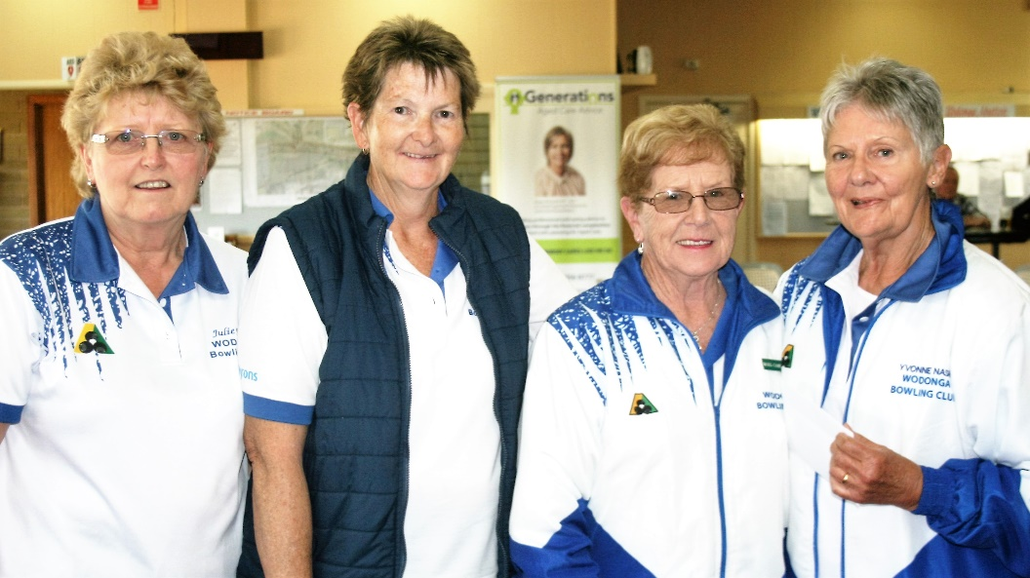
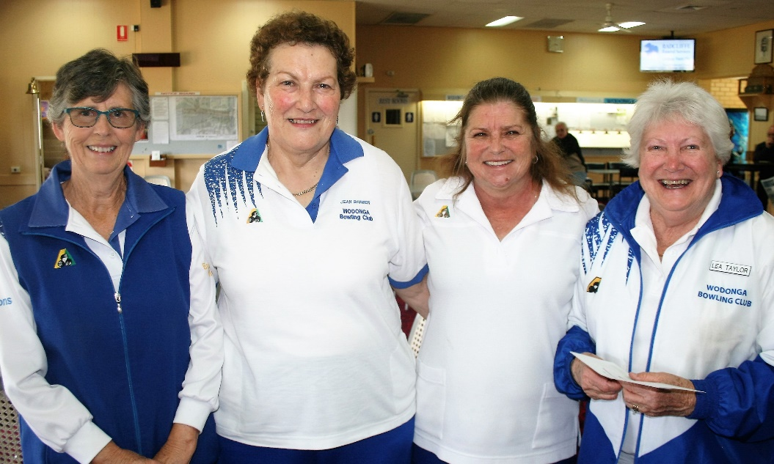
GENERATION’S Winning Rink: Elaine, Jean, Wendy, Lea
GENERATION’S Runners-up: Julie, Maxine, Marg, Yvonne YYYvonne
CLUB UNIFORMS:
At Its last meeting the Board of management discussed the suggestion put forward by a number of members that the club give consideration to “updating” our current pennant shirt.

While it was agreed that perhaps our pennant shirt could be “modernised’ the Board is well aware it would be difficult to require over 200 members to purchase new bowls attire. Therefore, it was decided that no action be taken on this matter until the issue has been canvassed with ALL members.

If it is decided that a change in uniforms should occur it will not be a major change and will not entail a change of colour from our predominantly blue and white. A change from these colours would mean the purchase of a complete bowls attire - shirts, trousers, shorts, skirts, jackets, pullovers, jackets – the list goes on.

The Club is now purchasing shirts for both men and women from the same supplier and having the shirts made from the most suitable material for wear in our warmer summer climate and having them cut to suit the natural different body shape of the genders.

Members are obliged to wear the club uniform in pennant games, club tournaments and championship events, however, in social events they can wear bowls shirts of their own choosing and perhaps their own design therefore if they choose to have some animal on their back e.g. a monkey, it is their choice! But ladies be assured a new Wodonga Bowling Club ladies’ shirt will not have a bulldog on the back.

GENERATION FOURS
Once again sponsored by Generations Aged Care Advice, the annual Ladies Fours Tournament was held on Friday, 16th September with more than 50 bowlers competing. Unfortunately, due to the uncertainty of the weather early in the day, several visiting teams withdrew but, as it turned out, fine conditions prevailed and those who took part thoroughly enjoyed a great day of competitive bowling.
Congratulations to Wendy Kelly, Lea Taylor, Jean Barber and Elaine Gilby(s) who were winners on the day and to Yvonne Nash, Marg Cameron, Julie Jones and Maxine Neilson(s) who were runners-up and Cicely Wilson, Betty Dower, Lesley Duncan and Marg Bedford(s) who came in third.
The Club is once again extremely appreciative of the generous support extended by GENERATIONS for this tournament.

OCTOBER DATES TO REMEMBER:
Mon 3 Ladies Information Meeting 1.00pm
Thu 6 Ladies Consistency Final 10.00am
Sat 8 Weekend Pennant PRACTICE 12.30pm
Tue 11 Mid-week Pennant PRACTICE 10.00am
Sat 15 Weekend Pennant PRACTICE 12.30pm
Tue 18 Mid-Week Pennant Week 1 10.00am
Sat 22 Weekend Pennant Rnd 1 1.15pm
Tue 25 Mid-Week Pennant 10.00am
Sat 29 Weekend Pennant Rnd 2 1.15pm
Sun 30 Men’s Club Singles C’ship Rnd 1 on or before. 10.00am
CHRISTMAS RAFFLE:
Before we know it Christmas will again be here and once again the Club will be conducting the annual Monster Christmas Raffle which is a great source of revenue and assists greatly in keeping the club afloat.

As in past years’ volunteers are required to man the selling booths during the very busy period leading up to Christmas and an earnest request is made to all members, if at all possible, to assist in selling tickets at various sites during this period. Please add your name to the list that will be on the Club notice board shortly.

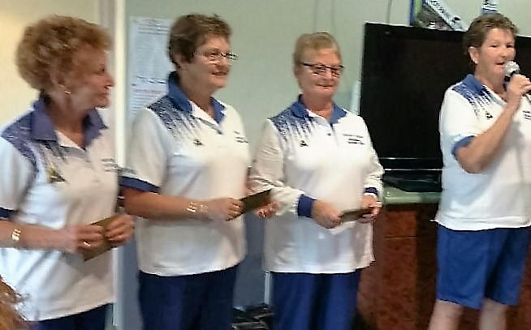
90th ANNIVERSARY OF OPENING OF THE GREEN
The 26th of this month marks the 90th anniversary of the opening of Wodonga Bowling Club’s first green; four rinks situated on the Hovell Street end of the Goldy Elwood Green.
The Club considered whether or not to acknowledge this occasion in some formal way, however, after some thought decided we would leave any celebration of the opening of our greens for another ten years. Let’s hope that we are all still around to join in the party.
Towards the end of this NEWSLETTER we have included a report on the gala day gleaned from an article published in the local newspaper at that time and also some photos of the day.

O&M LADIES OPENING:
Congratulations to Maxine Neilsen, Marg Bedford, Joan Boyd and Dawn Fraser, pictured left, who won the Fours Event at the O&M Association Ladies Opening Day.

Maxine was so happy she decided to sing a song or two.

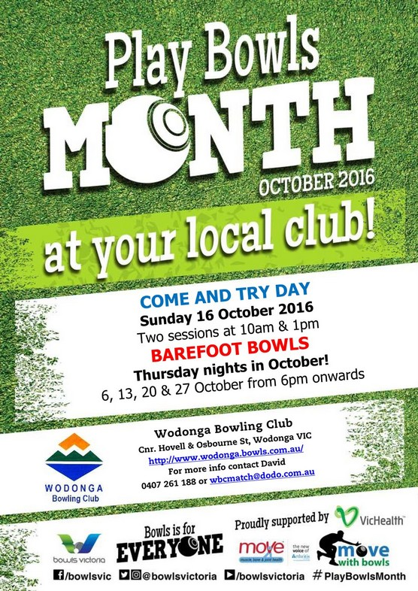
WELCOME NEW MEMBERS:
The Club extends a very warm welcome to Wendy Kelly, Lesley Duncan, Marlene Ellis, Susan Beer and Ray Beer who have joined us this month. All members hope you enjoy your bowls at Wodonga.
COME AND TRY DAY:
Over recent years Bowls membership has been in decline at our Club and most other clubs. In an effort to stem the tide clubs are encouraged to promote themselves as being social, friendly and welcoming venues to all age groups.

Wodonga Bowling Club has taken this advice on board and during the month of October will be running “Play Bowls Month” – a come and try bowls at no cost. On Sunday 16th October the Club will be conducting a COME AND TRY DAY with two sessions at 10am & 1pm. All members are requested to encourage all of their non-playing friends and relatives attend one of these sessions and give the game a try.

Non-playing friends and relatives could also be encouraged to join in “Barefoot Bowls” which is our summer “Business House” bowling programme which will be held at the Club on Thursday evenings, October 6th, 13th, 20thand 27th from 6:00pm onwards.

CLUB DIARIES:
The Club diaries are currently at the printers and members can expect copies to be available well before pennant competition commences. This means very shortly.

Once again the Club owes Mike Bodman a big thank you for his hard work in the production of the diaries with most members not being aware of how onerous the task is of preparing for the publishing of the diaries.

Having to wait on pennant draws and championship dates from O&M Bowls, the withdrawal or inclusion of sponsors adds and the alteration of members’ phone numbers at the last minute all contribute to a restructure of the publication which in turn contribute to delays to the final production date.

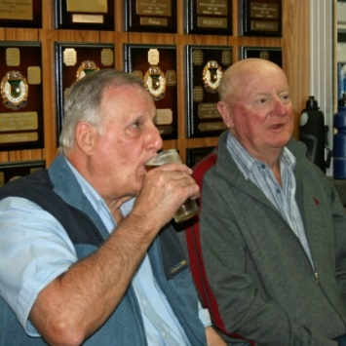
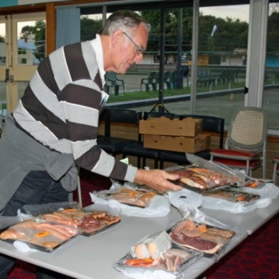
FRIDAY NIGHT HAPPY HOUR
5.30 pm to 6.30 pm

Reduced drink prices
Meat tray & voucher raffles
Members Draw
Every Friday night.
Come and enjoy good fellowship, a chat and drinks with friends.

Melbourne Cup Day
Tuesday 1st November 2016 ~ 10.00am
2 Bowl Mixed Triples
Team or Single Entry @ $54.00 per team
Includes
2 course Luncheon
Chicken & Dessert with Champagne
Sweeps, Raffles and Fashions on the Field
PRIZEMONEY
1st $150 ~ 2nd $120 ~ 3rd $90
ENTRIES CLOSE: 25th October at 2.00pm
Please place name on sheet provided at the Clubhouse or phone
Maxine Bounader 0402 311 927
Or Brian Gilby (02) 6024 6447

CLUB OPENING, OCTOBER 1926 – 90 YEARS AGO.
A GRAND AFFAIR:

At the first Annual General Meeting of Wodonga Bowling Club, held on Tuesday 14th September 1926, Secretary Eddie Owens reported an audited statement of the club’s assets and liabilities indicated assets exceeded liabilities by £190/10/9. Great progress had been made with the formation of the green and, using voluntary labour, a pavilion had been constructed between the green and Hovell Street. This was a remarkable effort for a club that had only been constituted twelve months previously and members were now looking forward to the opening in the next month.

At this meeting Percy Lingford tendered his resignation as President explaining he had accepted the position of Shire Engineer with Rutherglen Shire Council and would be moving to reside in that town. Mick Martin and many others expressed regret at Percy’s departure and later in the meeting he was unanimously elected the club’s first life member for his great service to the club in the relatively short time it had been in existence. The club also honoured him by requesting he open the green on Saturday 23rd October 1926. Mick Martin was then elected the new President, a position he held for the next 22 years, and Eddie Owens once again elected Secretary/Treasurer.

The opening was a grand event with many dignitaries, visitors, members, clergymen and local citizens in attendance. There was no shortage of orators.

President Mick Martin welcomed all in attendance and introduced Percy Lingford who expressed great pleasure at being asked to perform the opening. He then went on to say,
“It was hard for those not directly associated with the movement to appreciate the trials and tribulations and the adverse criticism that the committee had to contend with. There are many who are ever willing to pour cold water on any movement inaugurated to make the idle moments of life a little more pleasant. However, all these troubles have been overcome and in my opinion bowling is a most enjoyable recreation, and the finest thing that is known for cementing together the brotherhood of man.”

Lingford then presented a flag in the club’s colours of navy blue with a white border and white W.B.C. in the centre to Secretary Owens and asked him to hoist it. Owens in turn presented Lingford with a club life membership badge in recognition of his services to the club. In acknowledging the presentation, Lingford said that while he appreciated this marked method of recognition he felt there were others more deserving stating,
“When the temperature was well over one hundred degrees there were many who worked manfully and devoted much of their time in the interest of the club.”

The President’s wife, Mabel Martin, was invited to throw the first jack and Lingford’s wife, Kathleen, given the honour of rolling first bowl. Lingford then declared the green open and invited all present, the ladies in particular, to participate in a game of bowls.

During afternoon tea many visitors congratulated the club and wished them every success. M.L.A. Beardman complimented the club in the way it had overcome many difficulties and Shire President Charlie Pollard said that outstanding progress had been made and members of the club deserved every credit for the way they had worked.

Archdeacon Potter, President of the Wodonga Progress Association, expressed pleasant surprise at the number in attendance and moved a most hearty vote of thanks to the ladies for the kind assistance that afternoon. Representatives of a number of visiting clubs spoke, accepting invitations to visit in the future and offering assistance to the club whenever it was required.

All who attended voted the afternoon a great success. Mick Martin was delighted that Wodonga at last had a bowling club, committee members were optimistic for the future of the club and all were quietly satisfied with what had been achieved in a relatively short time.

Photos of the Opening Day on next page:

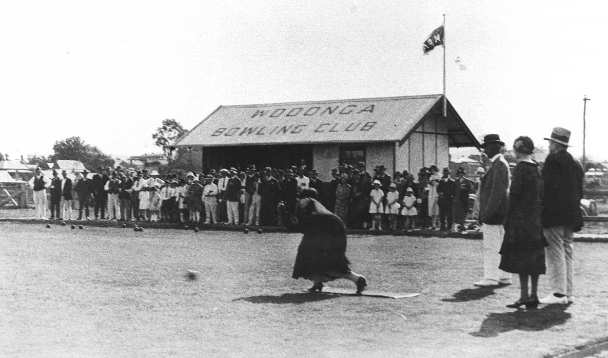
KATHLEEN LINGFORD ROLLS THE FIRST BOWL
23rd October1926.
(Standing behind: Mick Martin, Mabel Martin and Percy Lingford.)
Left:
Mick Martin

Right:
Speeches

Below Left:
Girls on the Green.

Below Right:
Percy Lingford
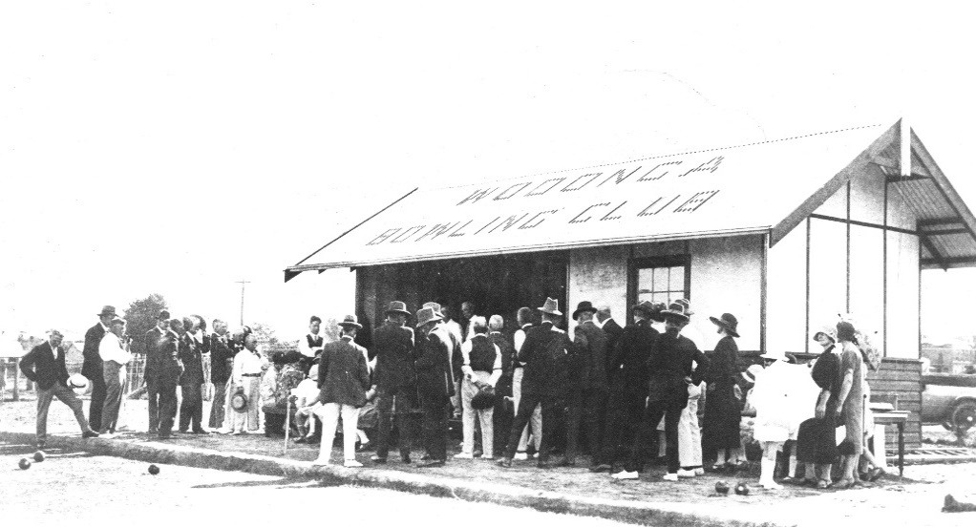
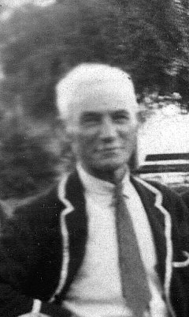
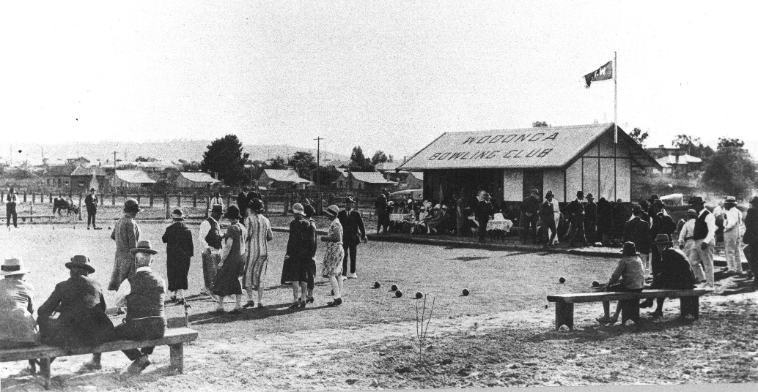
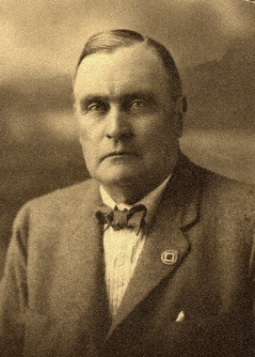

Mon | Tues | Wed | Thurs | Fri | Sat | Sun
31 |  |  |  | Happy Hour  &  Raffles | 1  Men’s Club  Triples  Championship  Jackpot  Pairs | 2
3  Greens  Closed  Maintenance  Ladies’  Meeting | 4  Ladies’  Social | 5  Men’s Social  Pairs 2x4x2 | 6  Ladies’  Social | 7  Happy Hour  &  Raffles | 8  Weekend  Pennant Practice | 9
10  Greens  Closed  Maintenance | 11  Ladies’  Social | 12  Men’s Social  Pairs 2x4x2 | 13  Ladies’ Club  Consistency  Final  Ladies’  Social | 14  Happy Hour  &  Raffles | 15  Weekend  Pennant Practice | 16  Men’s  Triples  Championship
17  Greens  Closed  Maintenance | 18  Mid-week  Pennant  Round 1 | 19  Men’s Social  Pairs 2x4x2 | 20  Ladies’ Social | 21  Happy Hour  &  Raffles | 22  Weekend  Pennant  Round 1 | 23
24  Greens  Closed  Maintenance | 25  Mid-week  Pennant  Round 1 | 26  Men’s Social  Pairs 2x4x2 | 27  Ladies’ Social | 28  Happy Hour  &  Raffles | 29  Weekend  Pennant  Round 2 | 30  Men’s Club  Singles  Championship  Round 1
OCTOBER

