ISSUE 3 – NOVEMBER SEASON 2016-17
WEBSITE – www.bowls.wodonga.com.au
NEWSLETTER

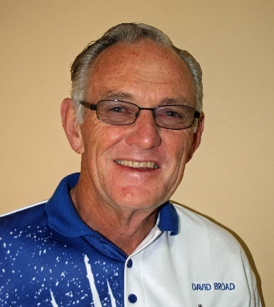
FROM CHAIRMAN DAVID

HAVELOCK STREET CONSTRUCTION:
Unfortunately, the Wodonga Council continue to play “hard ball” in our negotiations with them over protection of Club Assets, even though the road construction contractors have been very active in recent weeks.

Thus, on the 24th October I again sought an urgent meeting with Council Chief Engineer Leon Shultz, following his letter of the 12th September that matters should be able to be resolved in 4-5 weeks. Telephone contact with Vic Track though, suggested 2-3 weeks. The meeting, the following day, was a “complete fizzer” with only two contractor representatives, the Project Engineer and Project Foreman in attendance, and no further update available on our very reasonable request for assistance, which has now been under discussion around five months. The reason given was that Council was in ‘Caretaker Mode’ awaiting the appointment of new Councillors, even though over the same period “Contracts” have been let for the road works and “settlement of the land purchase” has obviously been reached with Vic Track, as part of this 1.5-million-dollar project, largely being funded by the Federal Government.

This of course follows the original reply in July from Council CEO Patience Harrington, where the Club was basically insulted with an offer of approximately one third of its monetary request –which in my view was an offer throwing “peanuts to the monkeys, to simply shut them up”. We also had an early Sept meeting between various Board Members, the Council project engineer Theo Panagopoulos and a representative of Vic Track, as the new road alignment completely extinguishes the Club’s previous lease of land from Vic Track. We now have been formerly advised of this lease cancellation, and seemingly as a result of previous comments detailing where Council has forced Band Members to traverse over WBC land for access this past 2-3 years, without any consultation, a new entrance crossing has finally been provided for the Band. But the Bowling Club, which has been fully cooperative on every project issue, continues to be treated like it doesn’t even exist!!! We now have considerable overburden soil over our land title, does it matter, well not if we were being treated respectfully as a valuable community organisation, but we are not! Where to from here? Well it’s largely Federal Project Money, so if the next ten days don’t result in fair play, what other option do we have??
David’s Report continues next page:

CATERING:
Prior to the last Board Meeting, a discussion was held with Joan Boyd and Marg Hickey, with Paul and Louse Laird also in attendance, who indicated they were trying to get a “foot in the door” in the Restaurant Business in Wodonga. Accordingly, they would be interested in leasing the WBC kitchen and function area three days a week for a trial period. It was agreed that from the 1st Nov.(Cup Day ) the Club would welcome such a venture with restaurant standard meals available on Thursday, Friday and Saturday evenings. Advertising has already commenced and members are urged to support Paul and Louise at every opportunity. They will virtually look after all catering including pennant salad rolls or sandwiches, so the extra benefit is that this arrangement will take most of the volunteer work away from members in respect of the kitchen.

LED LIGHTING:
Observant members will have noticed we have finally had success under this State Government subsidised scheme, with 122 brand new bright 1.2mt fluorescent tubes having been replaced at a total cost of $736, which should dramatically help with our power bill in the future, as well as enhancing the overall appearance of the Club Rooms.

WORKING BEES:
My thanks go to John Boyd and John Evans who fronted for the first working bee, but I am sure we can do much better, with the next one scheduled for 9am on Monday 21st November. Just bring a shovel, rake, broom or mower, there is always something that needs to be done, and likewise inside the club house some tidying up or cleaning is always a help in improving our image. It should be noted by all of course that John Boyd is now helping Tony Smedley with maintenance of the Club surrounds, for which everyone should be extremely grateful.

THURS.BUSINESS HOUSE/NEIGHBOURHOOD BOWLS:
To those that helped kick off the Barefoot Bowls Competition last Thursday evening, my grateful thanks. With winter revenue seriously down we are attempting to run for six weeks until the 1st Dec., but if we could add to the current 16 teams it would assist greatly, so contact your neighbours or relatives, and see if they would like to participate in a truly fun night.
CHRISTMAS RAFFLE:
The Christmas Raffle selling roster is now up on the notice board, so please check it out and if your date is unsuitable arranging your own swap would be extremely helpful. I may also so need some assistance with set up and pick up of small table, chairs, sign and money on a couple of occasions as at this stage the dates for Christa’s visits to Peter McCallum are not yet known. Thank you all.
DAVID

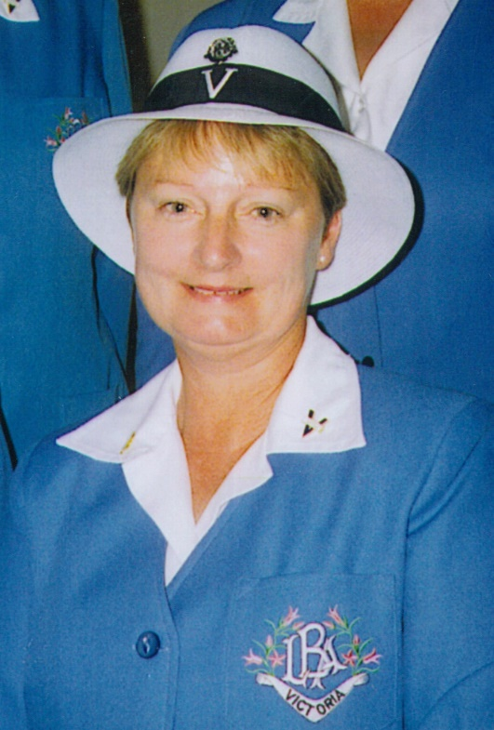
WINNERS ARE GRINNERS:
Congratulations to:
Margaret Vlacci.
Winner of the Club Ladies’ Consistency Championship.
Margaret Bedford.
Winner of the O&M Ladies’ 60 and Over Singles.
Paul Davies and Bob Harbridge.
Winners of the O&M Men’s 60 and Over Pairs.

O&M LADIES’ 60 AND OVER SINGLES:
Former state and club singles champion Margaret Bedford is again playing high standard bowls and is to be congratulated on winning the O&M Ladies’ 60 and Over Singles Championship. In a closely fought final Margaret defeated Kerri Leask from Benalla who in the semi-final defeated Wodonga’s Cheryl Morgan. With a bit more luck Cheryl could have won her game against Kerri and we would have had an all Wodonga final. Once again congratulations to Margaret who now goes on to play for the state title.

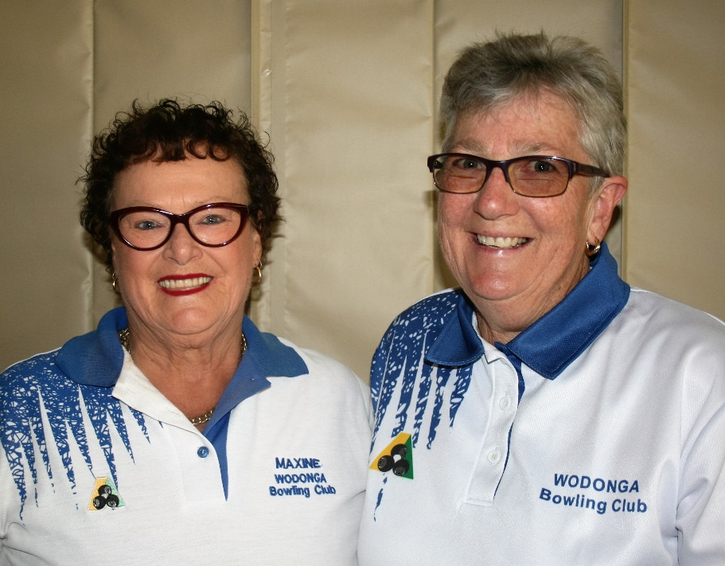
LADIES CONSISTENCY HANDICAP:
Congratulations to Marg Vlacci on winning the Ladies Consistency Handicap with a close victory over Maxine Bounader. Played last Friday week (21/10) on a day ideal for bowls on a good paced green the game treated interested spectators to a display of excellent draw bowling. Margaret got away to a good lead and half way through the event looked to be well in control. However, Maxine picked up her rhythm and started to make good headway and towards the end looked to have a chance of overtaking Margaret but was unable to make up the deficit with Margaret holding on to win an extremely interesting well played tussle.

JACKPOT PAIRS
The latest Jackpot Pairs Competition came to a close on Saturday October 15th with more than 70 players chasing the top prize of $600. After some very keen competition, Tony Smedley and Mick O’Brien shared the prize with Mike Bodman and Geoff Bath whilst Adam Strelschenko and Rick Gillman picked up some handy money by winning the Losers Jackpot.
A BBQ was held after completion of play to help mark the 90th Anniversary of the opening of the greens.
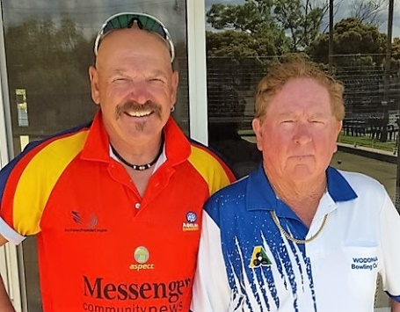
O&M MEN'S 60 AND OVER PAIRS
Congratulations once again to Paul Davies and Bob Harbridge who for the second year in a row won the O&M Men's 60 and Over Pairs championship. Playing at YMGCR against a pair from YMGCR on Thursday 27th the Wodonga pair didn’t have it all their own way but going into the last end were five shots up. The opposition managed to score two shots – not enough – and the Wodonga pair held on to the title they won last season. A great effort.

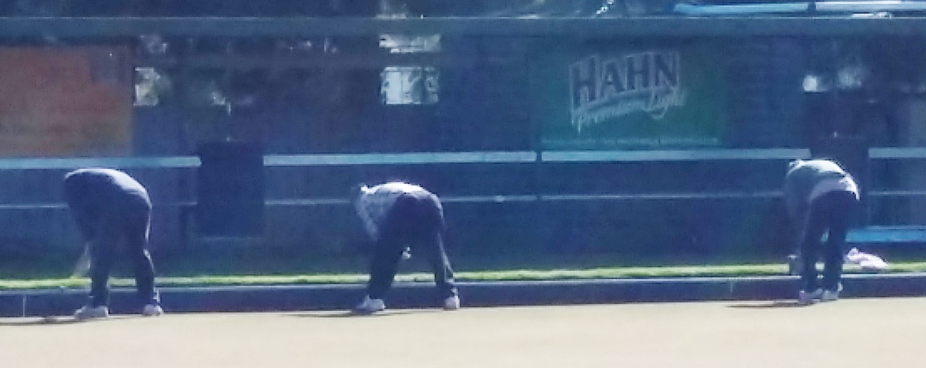
HEAD DOWN BUM UP AT THE WORKING BEE

FROM BOWLS VICTORIA

VICTORIAN OPEN:
The 2016 Victorian Open runs from November 5 to 11 and has again broken all records, with nearly 1,500 entries - mostly from rank-and-file club bowlers.

There are 1,487 entries this year. That's nearly a 20% increase on 2015's figures, and a 57% increase in the past two years. Wodonga members Rick Gillman and Maxine Neilson have entered this year.

Seventeen bowls clubs around Shepparton and the Goulburn Valley will be used for matches during the tournament with games being played at the following venues:- Shepparton Park, Dookie, East Shepparton, Euroa, Hilltop, Katandra West, Kyabram, Merrigum, Mooroopna, Numurkah, Numurkah Golf, Shepparton Golf, Shepparton RSL, Stanhope, Tallygaroopna, Tatura and Wunghnu will be used as tournament venues.

CHAMPION OF STATE PENNANT IS BACK:
Moama Bowling Club and Bowls Victoria will combine to reinstate the Champion of State Pennant series on the State Calendar of Events in May 2017. This will enable Region Pennant-winning teams from all over Victoria to pit their skills against each other in the ultimate test of bowls supremacy.

The best club teams from Victoria’s 11 Country Regions, plus Melbourne‘s Metropolitan Pennant competition winner, will take part in the championships. There will be separate events for both Saturday and Midweek Pennant competitions conducted between the 5th and 11th May 2017.

Champion of State Pennant will be the first major event held at Moama Bowling Club’s new world-class bowls facility – scheduled for completion in late April 2017.

BOWLS VICTORIA PRESIDENT:
Barbara Gilbert (Ocean Grove BC), steps up from the Deputy President’s role, the position she has held for the past two years, to become the new President of Bowls Victoria for the next two years. John Inglese (Richmond Union BC) has been elected Deputy President.

Outgoing President John Fisher OAM (Rutherglen BC) will remain on the Bowls Victoria board as a Director. He has been a Director since Bowls Victoria's inauguration in 2009, and will continue in this capacity.
SINGLE GENDER EVENTS:
Members would be aware that bowling clubs in Victoria are obliged under the Equal Opportunity Act to apply to Victorian Civil and Administrative Tribunal (VCAT) for a declaration allowing the advertising and conduct of single gender bowls events and would also be aware that some months back Bowls Victoria applied to VCAT for a blanket exemption so as to allow clubs to conduct and advertise single gender events.

However, because of a recent decision by VCAT which encourages organisations such as Bowls Victoria to undertake their own assessment as to whether a conduct is in breach of the Equal Opportunity Act last week Bowls Victoria withdrew their application.

Currently clubs are not required to apply for exemption to run single gender events such as club singles and pairs championships because these events are covered by the elite pathways exception as they proceed eventually to state and possibly national championships.

It has been reported that some clubs are choosing not to apply for an annual exemption from VCAT under the Equal Opportunity Act but to mitigate the risks of a discrimination claim are offering:
Club Triples Championships (open, not limited to either gender);
Club Fours Championships (open, not limited to either gender); and
Club handicap events (open, not limited to either gender).

WODONGA BOWLING CLUB
SPONSORS
MON | TUES | WED | THURS | FRI | SAT | SUN
Greens  Closed | 1  Melb. Cup  Mixed Triples | 2  Men’s Pairs  2:4:2 | 3  Ladies’ Social | 4  Happy Hour  &  Raffles | 5  NO  Weekend  Pennant | 6
7  Ladies’  Meeting  Greens  Closed | 8  NO  Mid-Week  Pennant  Ladies’ Social | 9  Men’s Pairs  2:4:2 | 10  Ladies’  Social | 11  Happy Hour  &  Raffles | 12  Weekend  Pennant | 13  Men’s State  Singles  Champ’ship  Rnds 1 & 2  Men’s Club Singles
14  Greens  Closed | 15  Mid-Week  Pennant | 16  Men’s Pairs  2:4:2 | 17  Ladies’ Club  Singles  Champ ’ship  Rnds 1& 2 | 18  Happy Hour  &  Raffles | 19  Weekend  Pennant | 20  Men’s State  Singles  Champ’ship  Rnds 3 & 4
21  Greens  Closed | 22  Mid-Week  Pennant | 23  Men’s Pairs  2:4:2 | 24  Ladies’ Club  Pairs  Champ ’ship  Rnds 1& 2 | 25  Happy Hour  &  Raffles | 26  Weekend  Pennant | 27  Men’s State  Fours  Men’s Club Singles  Champ’ship
28  Greens  Closed | 29  Mid-Week  Pennant | 30  Men’s Pairs  2:4:2
NOVEMBER
“FRIDGE CALENDAR”

