NEWSLETTER

ISSUE 5 – FEBRUARY SEASON 2016-17

WEBSITE – www.wodonga.bowls.com.au

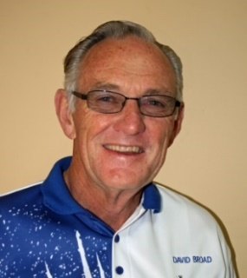
FROM CHAIRMAN DAVID:

CHRISTMAS RAFFLE:
A record profit of more than $9,300 was achieved, and my thanks go to almost every member for returning their book, those who helped to sell in High Street and the shopping centres, and particularly to John and Lorraine Gill for selling tickets over six Saturday mornings at the Apco/Servo/IGA.

CATERING:
Unfortunately, Paul and Louise Laird have decided it is too difficult trying to establish a restaurant in Wodonga, while still operating in Holbrook, and they ceased operation just prior to Christmas. An advertisement in the Border Mail and on the Website has attracted some interest and currently the Board is in discussion with a chef/caterer from Albury who has displayed some enthusiasm to be involved in a business deal with the Club. Further negotiation is to occur. Iin the meantime we are basically back to operating the kitchen ourselves, so anyone able to assist as we try to cater for functions, pennant or tournaments, please indicate your willingness to Club Manager Bob.

BUSINESS HOUSE, NEIGHBOURHOOD, FAMILY - TWILIGHT BOWLS:
Yes, it’s on again 6.30 till 9PM every Thursday night in February commencing on the 2nd, so again anyone who can assist please make it known to either Brian Gilby, Rob Taylor or myself – and if you can drum up extra teams, please do so ASAP.

CLUBHOUSE STORAGE:
The Board is currently investigating a solution to the shortage of storage space within the confines of the Clubhouse, as the ladies’ room and the board room are inappropriate places for ladders and excess chairs, with the latter often required for overflow food preparation.

HAVELOCK STREET AND COUNCIL:
Following a three-page letter to the Mayor dated 11th January, which prompted immediate phone calls from the Council CEO Patience Harrington, Bill Fraser and myself met with the Mayor Anna Speedie and the CEO on Tues.24th January. We were advised by letter that Council’s 50% contribution to protective fencing was all that was on offer, and it was the “Councillors” who were against any increase for fear of setting a precedent! I ask you how many other ‘brand new road reserves’ does Council create that make a huge adverse impact on abutting property, in this case a 200 member plus community sporting organization - “NONE”! However, we were promised further contact very early in February, as the CEO endeavours to see how we might be further financially assisted through other avenues. We are also in discussion with the road construction contractors Excel Gray Brunei as to whether they can assist with completion and sealing of our Hovell Street car park. Stay tuned with your fingers crossed!

ANNUAL MEETING SCHEDLED FOR THURSDAY 30th MARCH, 2017:
There is an urgent need for all members to seriously consider their ability and willingness to assist the Club going forward, both with the conduct of bowls and Board administration. Many current appointees are set to step back and if the Wodonga Bowling Club is to continue to function successfully new enthusiastic blood is required to take up the various positions.

David
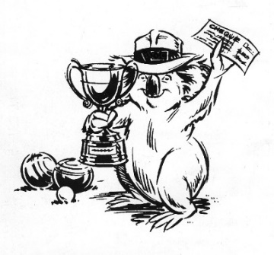
WINNERS ARE GRINNERS:
Congratulations to:
Kylie Whitehead.
Winner of the LADIES’ CLUB SINGLES CHAMPIONSHIP.
PETER McLARTY.
Winner of the MEN’S CLUB SINGLES CHAMPIONSHIP.
Margaret Bedford.
Winner of the O&M LADIES’ OVER 60 SINGLES CHAMPIONSHIP.
Paul Davies, Bob Harbridge.
Winners of the VICTORIAN MEN’S OVER 60 PAIRS CHAMPIONSHIP.
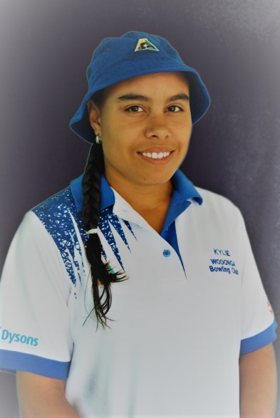
LADIES’ CLUB SINGLES CHAMPIONSHIP:
The semi-finals of the Ladies Singles Championship played on December 8th saw Kylie Whitehead, the reigning Club Champion; defeat former State and Club Champion Marg Bedford with Lyn Winter managing a good win in a hard-fought tussle by just a few shots over Maxine Nielson.

Later in December in the final played before a good crowd of members Kylie won her fourth Club Singles Championship with a 25-13 win over former champion Lyn.

In the early stages of the event Lyn matched it with the Victorian representative but Kylie gradually got on top. Able to pull out top shots whenever the occasion demands is the hallmark of a really good player and Kylie demonstrated once again just how good she is.

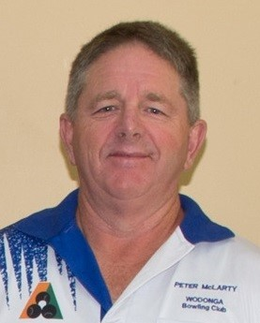
MENS CLUB SINGLES CHAMPIONSHIP:
Watched by members of his family, as well as a good crowd of interested Wodonga members, Peter McLarty won his first Men’s Singles Championship with a three-shot victory over Paul Davies.

Peter got away to a good start to set up his win by jumping to a 13-4 lead before Paul fought back with good consistent draw bowling to get within two shots. However, Peter steadied and managed to hold off Paul to take out the coveted prize.
To say Peter was delighted with his win is an understatement! Both Peter’s parents and his brother Ray have won club singles at other clubs and consequently up till now have had bragging rights over Peter. Not now!

ANNUAL AUSTRALIA DAY MAJOR-MINOR PAIRS:
Generously sponsored once again by Get Off Road 4 x 4 the Annual Australia Day Major-Minor Pairs attracted 80 bowlers from nine district clubs. Played in fine weather with the greens running well sectional play was the order of the day with three games of 12 ends being played prior to the luncheon break. The ten Section winners then played off over four “sudden death” ends with the Wodonga team of Geoff Brown and Alec Green meeting Lesley Duncan(Wodonga) and Ron Miller(Kiewa) in a play-off final. Lesley and Ron put in some great bowls on the final end to run out winners on the day and take home the major prize money.

Other prize winners:
Stan Pickett and Ashley Bates Murray Lawn and Tony Smedley (equal 3rd),
Tyson and Tim Cromie(Yarrawonga), Gary and Ian Brimblecombe(Wangaratta),
Glenn McGuire and Fred Baldock, Paul Witham and John Hodson,
Laurie McDonald and Ian “Skeeta” Keats(Myrtleford), Brett Barton and Dale Mastenbroek(Kiewa).
FROM THE MATCH COMMITTEE:

This year the 'Australia Day' Major / Minor Pairs was played with some changes to conditions of play and also the format.

The first change was making the event an 'OPEN' event, and although not a total success, we did have a few mixed teams which was fantastic and all participants who commented about the day thought it was a great innovation.

The change from a 'two & walk" pairs to a 'Three Bowl Pairs' was also well received, and along with the Sectional Play format, whereby every team plays at least three games, was thought to be a good idea.

Many thanks must go to the ladies who organised the catering. This was a first as in the past we have bought in our lunch. Everyone concerned can be assured it definitely increased the money coffers on the day and was a great contribution towards making it an even better event than in previous years.

'Get Off Road 4x4' once again sponsored the day along with the prize money, and also contributed prizes for the raffle. The Club greatly appreciates their generosity. Any member looking for accessories for caravans and 4x4's, you need go no further than down to their business and talk to Terry or Robyn. When talking to them make sure you mention that you are from Wodonga Bowling Club,

THIS YEAR WAS A GOOD EVENT AND NEXT YEAR WILL BE EVEN BETTER!

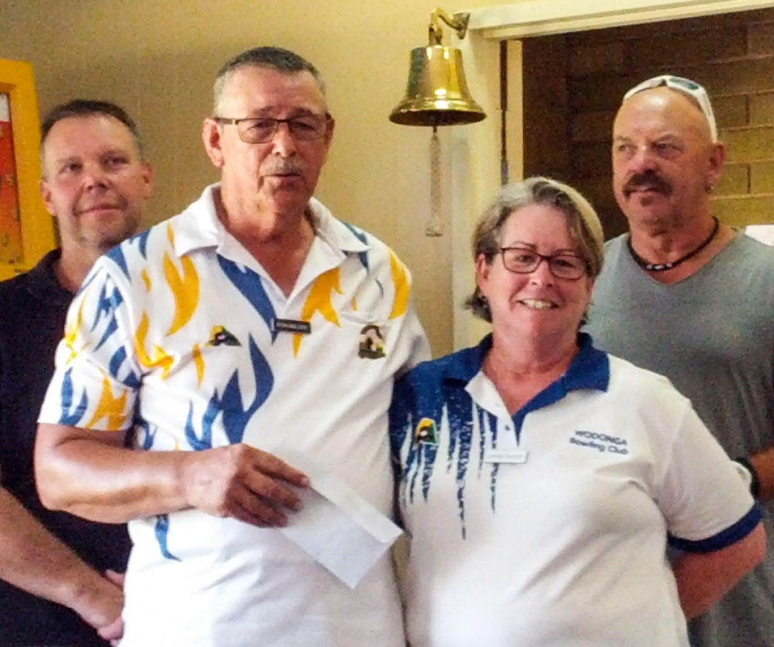
Left:
'Get Off Road 4x4' Annual Australia Day Major-Minor Pairs winners:
Ron Miller and Lesley Duncan.

In background Paul Davies and
Proprietor of 'Get Off Road 4x4' Terry Bradbury.

STORAGE:
Storage of surplus chairs, tables and items such as concert staging and other items of furniture that are only used occasionally has long been a problem at the Club. The Board is currently investigating how to solve this problem by the cheapest method and in particular is looking at the merits of acquiring a shipping container.

BBQ AREA:
The “spruce up work” has now been completed making the area much more attractive, safer and functional, but it needs to be kept clean to satisfy customers we are maintaining high standards of food preparation.

ANNUAL GENERAL MEETING:
In his notes on page one Chairman David reminds us that the Club’s Annual General Meeting will be held on Thursday 30th March. The need for careful management of the Club cannot be over stressed and all members are requested to give careful consideration to all committee and Board nominations.

MEN’S OVER 60 STATE PAIRS CHAMPIONSHIP:
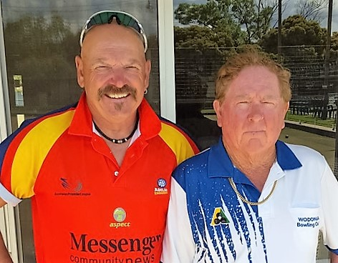
On the afternoon 8th of December, viewed by a large gathering of spectators, in fine but windy weather the final of the Men’s Over 60 Pairs Championship was played at Yarraville/Footscray Bowling Club on a free running 'bent' grass green when the Wodonga pair of Paul Davies and Bob Harbridge, representing the O&M, met the champion pair from the Peninsula Casey Region.
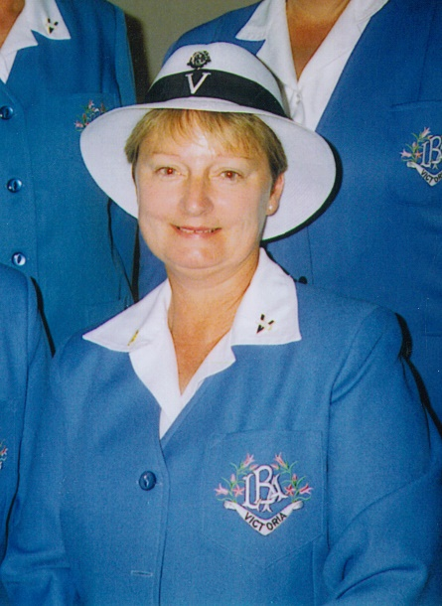
On the opening end the O&M team was able to convert the end into a five shot start, a two on the next end opened up nicely for O&M. However, the Peninsula team was able to score a three and a two on the next two ends. End five saw the O&M pair score a seven with the seventh shot just 15 inches from the 'jack'. Another five shots over the next two ends saw the O&M team open a match winning lead of 19-5. Bob's lead bowls were very telling and throughout the game put the opposition under extreme pressure. The Wodonga pair continued their good form and despite dropping two shots on the fourteenth end by the penultimate end they held a commanding lead - 23-12 therefore not requiring the final end to be played.
O&M LADIES OVER 60 SINGLES:
Margaret Bedford claims she is playing nowhere near to the standard she reached when she won the State Ladies Singles Championship a few years ago, however; despite her claim Margaret is still capable of playing outstanding bowls as she proved during December when she won the O&M Ladies Over 60 Singles.

In the final of this event Margaret defeated Kerri Leask from Benalla in a very tight game, the highlight being the high standard of draw bowling displayed by both Margaret and Kerri.

In the semi-final leading up to the final Kerri defeated Cheryl Morgan in another high standard close encounter.

WINNING TICKETS CHRISTMAS RAFFLE

Winner $3,000 Holiday Package-“Flight Centre”
Ticket No: 136: Mark Schlink
Winner $500 in Caltex Fuel Cards
Ticket No: 5680: Sharon Brady
Winner Woolworths $100 Gift Card
Ticket No: 5584: Paul Witham
Winner Coles $50 Gift Card
Ticket No: 5103: B. Crowhurst
Winner Coles $50 Gift Card
Ticket No: 4929: Liegh Millar
Winner Coles $50 Gift Card
Ticket No: 1554: Nicole Doughty

LADIES MEETING
Monday 6th February.
1:00pm
Guest Speakers:
Ovarian Cancer
Awareness Group
Agenda
- Match Committee Report
- Section Committee Report
- Delegate Report
- President’s Report
- Any further business.

FEBRUARY

MON | TUES | WED | THURS | FRI | SAT | SUN
 |  | 1  Men’s Pairs  2:4:2 | 2  Ladies’ Social | 3  Happy Hour  &  Raffles | 4  Weekend  Pennant | 5  Men’s Club Pairs  Rnds 3
6  Ladies’  Meeting  Greens  Closed | 7  Mid-Week  Pennant  Ladies  Social | 8  Men’s Pairs  2:4:2 | 9  Ladies’  Club Pairs  Rnd. 2  Ladies  Social | 10  Happy Hour  &  Raffles | 11  Weekend  Pennant | 12  Men’s Club Pairs  Rnds 4  Club Mixed Pairs
13  Greens  Closed | 14  Mid-Week  Pennant | 15  Men’s Pairs  2:4:2 | 16  Ladies’ Club Pairs Rnd. 3 | 17  Happy Hour  &  Raffles | 18  Weekend  Pennant | 19  Men’s Club Pairs  Club Mixed  Pairs
20  Greens  Closed | 21  Mid-Week  Pennant | 22  Men’s Pairs  2:4:2 | 23  Ladies’  Social | 24  Happy Hour  &  Raffles | 25  Weekend  Pennant | 26  Men’s & Mixed Pairs  Club  Championship  Finals
27  Greens  Closed | 28  Mid-Week  Pennant

