NEWSLETTER

WEBSITE – www.bowls.wodonga.com.au

ISSUE 4 – NOVEMBER SEASON 2016-17

THE BOARD OF MANAGEMENT EXTENDS TO ALL MEMBERS CHRISTMAS GREEETINGS AND BEST WISHES FOR THE NEW YEAR.

WODONGA BOWLING CLUB
SPONSORS

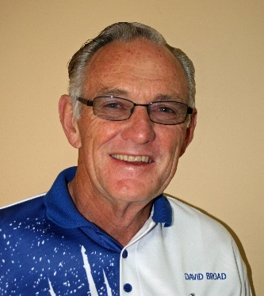
FROM CHAIRMAN DAVID:

HAVELOCK STREET CONSTRUCTION:
Despite continuing representation through Councillor John Watson regarding Council meeting the full cost of protective fencing, an impasse continues, even though Cr. Watson also felt our request to be perfectly reasonable. As most of the project is being funded by the Federal Government an approach has now been made the Cathy McGowan MP for Indi to help make an appointment with the Minister for Sport, The Hon Sussan Ley. The only other course of action bowlers might like to consider is mass attendance at Council Offices to individually seek to make appointments with the CEO Patience Harrington or the Mayor Anna Speedie – it wouldn’t really be a blockade, just ongoing representation seeking for the Club to be treated both fairly, and Members with respect and decency. Protective fencing was promised by the Project Engineer, months ago, and he is the person who we were directed to deal with.
Vic Track also saw our request as reasonable before cancelling our long-standing lease.

REPLACEMENT UNIFORM SHIRTS FOR PENNANT IN 2016-17:
Some possible options have been on display for a couple of weeks with room for members to make comment, and a wider range will be in the same location during December, but this clearly starts to divide opinion and make any decision to change or not to change more difficult.
A suggestion has been made that perhaps Members existing shirts could simply be screen printed on the back with a stylish” Wodonga” name/logo.

CLUB COACHES:
A plan has been in place for some time to name and photograph all Club Coaches for display in the Club House and on the internet. This should make it easier for all members, but particularly recent arrivals to know where they can seek assistance if their bowls are not tracking exactly as they would like, and hopefully this will happen in the near future.

BBQ AREA:
A decision has been made to “spruce up the BBQ” and make it much safer for operators, much more attractive, cleaner and healthier looking, which should help enhance the Club’s overall image which is vitally important when we host visitors in particular.

CHRISTMAS RAFFLE:
The Xmas raffle is progressing steadily, but it is these last three weeks where we can put the icing on the cake and make all the effort worthwhile. Members are respectfully asked to keep an eye on the Roster Sheet for street selling, and arrange their own swap if the allotted date is inconvenient, but also to make an effort to return their own raffle books by say Friday the 16th December, so as the last-minute rush to have them all securely in the Barrel, can be avoided.

Talking of Christmas, may I take this opportunity on behalf of the Board to wish every Member a very happy and healthy festive season with your various families, and may the Pennant run into Christmas be both productive and good fun (in pleasant weather hopefully), and remember to keep on supporting your Club in every way possible.
There will be no working bee in December or January unless otherwise advised, but my sincere thanks go to the dozen or so that turned up on the 21st November, particularly to clean up the car park and our Osburn St frontage.

FROM THE WEEKEND SELECTION COMMITTEE:

We are nearing the half way point of the season and so far, so good, we have a number of the Wodonga weekend pennant sides in their respective top four positions. The A3 side although bottom of that grade are only 16 odd points out of 4th position.
The committee would like to thank all weekend pennant players for availing themselves on the weekends, we know it is a commitment for the 14 weeks of home and away games plus another possible 3 weekends of finals, it is that commitment to your club that makes Wodonga a highly competitive and respected club in the Ovens and Murray Bowls Region.
A special thanks to the ladies of our club that play on the weekends, without you the club would struggle to field five weekend teams.
Remember the selection committee are duty bound to try and get some players qualified in a lower grade to allow us more flexibility in fielding strong teams when the finals begin, so we ask you to not only understand our situation but to also be patient. Remember pennant is not an individual event it is a team event and you are representing you club.
There are still positions up for grabs in higher grades and the selectors constantly looking for players that are performing at a consistent level every week to maybe give those players that chance. Over the past season and a half, the current selection committee have promoted quite a number of players, some of whom have played at least two grades higher, so the opportunities do exist.
We wish the players that have had health issues a speedy recovery and hope to see your names on the 'Available' list in the coming weeks, your team mates would love to see you back on the greens.
There are only 3 games remaining before the Xmas break so let’s all get that extra bit of training in and make sure of a few wins to set up a successful season. Good luck to all grades.
As this is the last newsletter for the year, the weekend selection committee would like to extend to all members of the Wodonga Bowling Club a very Merry Xmas and a Happy New Year to you and your families. To those members that may be travelling over the Xmas/New Year break have a good time and be safe.

Weekend Pennant Selection Committee.
Sunday 18th December
9.00am
CHRISTMAS HAMS
2 Bowl Triples - 2 games of 10 ends
Drawn Teams
$15 .00 Entry Fee
(Includes Christmas Fare Finger Food & Drinks at Happy Hour Prices.)

9.45am
CLUB SINGLES CHAMPIONSHIPS
Final – Ladies & Men’s
(Drinks at Happy Hour Prices.)

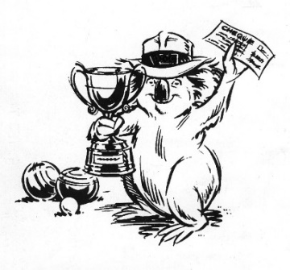
dddddM CHAIRMAN DAVID

WINNERS ARE GRINNERS:
Congratulations to:
Bill Luty, Ken Challis, David Smith.
Winners of the MEN’S CLUB TRIPLES.
Paul Davies, David Hillas, Alice Bounader.
Winners of the GENERATIONS MELBOURNE CUP TRIPLES.

MELBOURNE CUP DAY:

The annual Generations Aged Care Advice Melbourne Cup Day two-bowl Mixed Triples was once again held in ideal conditions and once again voted a huge success by all who attended becoming one of the most popular events on the club’s calendar.

A feature of the day was the table decorations featuring the “Flemington” roses in the gold vases and the general decorations in the Club itself. A big thankyou is extended to the many ladies who assisted in presenting the Club at its best on this occasion - in particularly to Deanna Gardiner for her work in highlighting the Melbourne Cup theme – and to the many others who worked so assiduously to make the day a great success.

Seventy-two bowlers participated playing two games of 14 ends with Alice Bounader, David Hillas and Paul Davies (s) taking home the major prize. Runners-up: Barry Pinkerton, Lyn Retallick and Alan Bounader (s). Third: Ron Harrison, Shelley Harrison and Bob Harbridge.

Following a most enjoyable lunch, prepared and presented by the new kitchen lessees Louise and Paul Laird, the annual “Fashions on the Field” contest was conducted and in a strong field in the Ladies’ Fashion Betty Dower greeted the judges with Joy Packer coming in second and Margaret Cameron taking out the prize for Best Hat. In the Men’s’ Fashion late entry Bill Miller received the judges nod but if there had been stewards in attendance we feel he would have been swabbed.

It was great our most generous sponsor Megan McGrath from Generations Aged Care Advice, accompanied by Dione Mills, could join us for lunch and present the prizes on the day and once again the Club is highly appreciative of Generations Aged Care Advice for their continued generous sponsorship of this popular day.

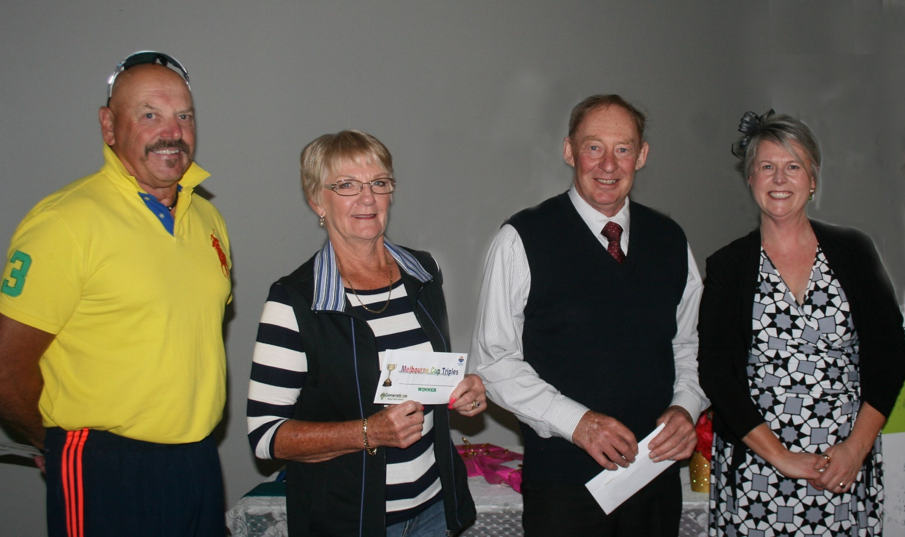
Winners of the GENERATIONS Melbourne Cup Day Triples:
Paul Davies, Alice Bounader and David Hillas with Sponsor Megan McGrath.

DATES TO MARK IN YOUR DIARY:
CLUB CHRISTMAS AND NEW YEAR TRADING HOURS:
Saturday 24th December Closes early evening after jackpot pairs.
Sunday 25 December Closed
Monday 26 December Closed
Tuesday 27 December Closed
The club will open 9:00am on Wednesday 28th Dec. when a short working bee will be held to wipe down various surfaces following the traditional fumigating of the premises, which will be carried out by Twin City Pest Control on Boxing Day.

Bingo will not be held on Tues. 27th.
DECEMBER:
Thu 1
Ladies’ Club Singles Championship Rnd 2
Thu 8
Ladies’ Club Singles Championship Rnd 3
Sun 11
Men’s Club Singles Championship Rnd 4 – on or before
Sun 18
Men’s Club Singles Final
Ladies’ Club Singles Final
Christmas Drawn Mixed Triples
Fri 23
Monster Christmas Raffle Draw

SINGLES FINALS – CHRISTMAS TRIPLES:
On Sunday 18th December, the final of the Ladies’ and Men’s Club Singles will be played concurrently which, based on last year, should be great viewing for spectators. This event will commence at 9:45am.
The club will again be conducting the annual Christmas Mixed Triples on the same day – Sunday 18th December - but this event will commence 45 minutes earlier than the singles championships – 9:00am - and is expected to conclude well before the finish of the singles which will give all the opportunity to view the important stages of the singles.

The Christmas Mixed Triples is always a fun event with plenty of prizes of hams, etc. and the club would like to see as many members as possible get into the spirit of the festive season and enjoy a relaxed and happy game of bowls before watching the conclusion of the Singles Championships.

Teams are drawn, two games of ten of two bowl triples are played, the entry fee is $15.00 which includes “Christmas Fare” finger food and drinks at “Happy Hour” prices.

CHRISTMAS RAFFLE:

The Monster Christmas Raffle conducted by the club each year is a great source of revenue and assists greatly in keeping the club “in the black”.

Coordinator, once again, of this year’s raffle, Club Chairman David, reports that ticket sales are going quite well but more volunteers are required to man the selling booths during the very busy period over the next weeks. If any member can help in this regard could you please ring David or add your name to the list on the club notice board.

The drawing of the winning tickets will be conducted at the club rooms on the evening of Friday 23rd December at 6:30pm.

As well as the usual Friday night “Happy Hour” drink prices there will be plenty of tasty finger food, raffles with good prizes and much merriment.

The Board is looking forward to making this event a festive occasion and is hoping as many members as possible can attend and participate in this happy evening of much fun and laughter. Not a night to be missed. You never know your ticket maybe first out of the barrel!

RAFFLE BOOKS – REMINDER.
THE CLUB WOULD LIKE TO THANK ALL MEMBERS FOR THEIR ACCEPTANCE TO SELL AS MANY TICKETS AS POSSIBLE IN THIS YEAR’S CLUB’S MONSTER RAFFLE.

TO ASSIST WITH THE ADMINISTRATION, IT WOULD BE APPRECIATED IF BOOKS OF SOLD TICKETS (BUTTS) BE RETURNED TO THE CLUB AT YOUR EARLIEST CONVENIENCE.

VALE
DALY Michael.
It was with deep sadness that members of our club earlier last month farewelled highly popular and esteemed member, Michael.
Our condolences to Michael’s family.
❖❖❖❖
MEN’S’ TRIPLES CHAMPIONSHIP:
Early in November the final of the Men’s Triples Championship between Geoff Bath, Mike Bodman and Peter McLarty(s) and the triple of David Smith, Ken Challis and Bill Luty(s) was played without a great deal of fanfare. After a very shaky start, Bill, Ken and David settled down and played some very good consistent bowls to take out championship and receive congratulations from fellow club members.

WIN AT OAKLANDS:

In ideal conditions, for the second year running, the team of Neville Smedley, Marty McGrath, Don McLean and Don Cameron(s) won the Over-60’s Competition conducted at the Oaklands B.C. on 24th November, winning their three games and finishing with 45 points with a team from Corowa Services in second place with three wins and 43 points. Sixteen teams from as far away as Bright competed on the day.

FROM THE BOARD:
At the last meeting of the Board of Management Chairman David reported that 33 outside plastic chairs that were broken, damaged and considered unsafe were destroyed and 35 new chairs have now been purchased and as we go to print volunteers are in the process of bolting them to frames.

The Board is investigating the cost of significantly improving and modernising barbeque area which would not only improve the visual aspect of the area but also improve the working conditions for those using this facility.

A number of complaints have been received by the Board regarding the poor standard of tiles in the ladies’ toilet. One of our sponsors, Beaumont Tiles, have agreed to supply the Club with tiles to the value of $715 in lieu of a cash donation and if this job is to proceed the Club would have to make their own arrangements for having the tiles installed.

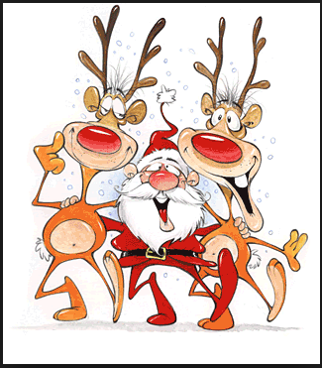
NEW MEMBERS:
The Club extends a very warm welcome to Margaret Dyer, Michelle Dyer, Bernie Webster and Allen Heriot whose membership applications were endorsed by the Board at its last meeting. All members hope you enjoy your bowls at Wodonga.

MON | TUES | WED | THURS | FRI | SAT | SUN
 |  |  | 1  Ladies Club  Singles  Rnd 2 | 2  Happy Hour  &  Raffles | 3  Weekend  Pennant | 4  Men’s State  Fours  Post Sect.
5  Greens  Closed | 6  Mid-Week  Pennant  Ladies  Social | 7  Men’s Pairs  2:4:2 | 8  Ladies’ Club  Singles  Rnd 3  Ladies  Social | 9  Happy Hour  &  Raffles | 10  Weekend  Pennant | 11  Men’s Club  Singles  Rnd 4
12  Greens  Closed | 13  Mid-Week  Pennant  Ladies  Social | 14  Men’s Pairs  2:4:2 | 15  Ladies  Social | 16  Happy Hour  &  Raffles | 17  Weekend  Pennant | 18  Ladies’  Men’s  Singles  Finals.  Christmas  Triples
19  Greens  Closed | 20  Ladies’  Christmas  Bowls | 21  Men’s Pairs  2:4:2 | 22 | 23  Monster  Christmas  Raffle  Draw  6:30pm | 24  Christmas Eve  Jackpot  Pairs  MERRY  CHRISTMAS | 25  Christmas Day  MERRY  CHRISTMAS
26  Greens  Closed | 27 | 28  Men’s Pairs  2:4:2 | 29 | 30 | 31  Jackpot Pairs
DECEMBER

