NEWSLETTER

ISSUE 7 – APRIL SEASON 2016-17

WEBSITE – www.wodonga.bowls.com.au

FROM CHAIRMAN DAVID:
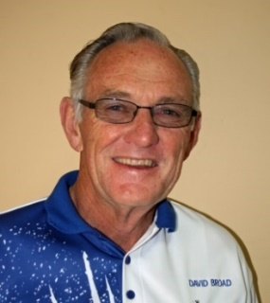

Even after a disastrous wet winter, Club profit was approximately $17,000 better than last year and at balance date the outstanding loan had been reduced by $10,000. This was achieved through greater Community use of our facilities and a push to minimise or reduce costs at every opportunity. For example, electricity costs were down by $5000 for the year and February power charges this year were half what they were in 2016. Further power savings are still a possibility!
Our magnificent band of members who have slaved in the kitchen over many years, to cater for functions and our own Club events, started to feel the strain so efforts were made to find a commercial operator to cost share the benefits of the many increasing opportunities to attract outside revenue to the Club. We now have a new operator in Tim Howe who is performing admirably and professionally and I would urge Members to give him your full support.
The dedication of Members to get behind the annual Christmas Raffle saw a record profit for the third year in a row, more than $9,000. The support of Flight Centre and Mark Schlink at the Water Tower Caltex service station is also gratefully acknowledged.
Although revenue from Bingo and Twilight (Business House) Bowls has been down in recent years, I would like to pay tribute and thanks to those dedicated members who have ensured that these extremely valuable events continue to be conducted. They are an important source of finance to support operation of the Club, particularly Bingo, and expose our very existence and operation to many in the Community to whom we have previously been unknown. Bingo is the regular weekly slog and we could do with the support of helpers. Once again, a huge thank you to those involved, who I have attempted to recognise throughout the year in the Newsletter.
Likewise, I have often mentioned our magnificent team of Gardeners, those that have volunteered to BBQ for twilight bowls or corporate functions, with the latter having been more numerous than ever before, and in this area compliment must be paid to Manager Bob for being prepared to take on multiple bookings at a time, especially in the run up to Christmas.
Special thanks go to Brian Gilby and Bill Miller for their continued efforts in attracting sponsorship for the Club, both as a general source of revenue and to boost Tournament prize money.
I wish to also recognise the hard work undertaken by our Ladies’ and Men’s Match Committees, Bowls Presidents Gary and Joan and their respective deputies, and the difficult task of those wrestling with selection each week. On behalf you all, and personally, special thanks go to every member who has fulfilled any of the above roles. Without such Member commitment, the Club simply cannot function. In this regard the lack of current nominations for the 2017-18 season is extremely disappointing. Sooner or later every Member should put their hand up to assist with the operation of the Club, because it cannot be continually held up by the same 20% for the benefit of everyone else.
During the recent illness of our hard-working greenkeeper DJ, we have seen a band of Members step up and continue to maintain our greens at a high standard, so much so that the O&M chose to play the A1 grand final here at Wodonga. Regulars like Tony Smedley, John Boyd, David Jackaman and Paul Smythe were further assisted by Rob Taylor and Marty McGrath, and I think they all deserve a special round of applause.
This is a summary of undertakings given at various meetings, which have now been all confirmed and agreed/acknowledged by the Board:-

- Council will only pay 50 % of the fence construction, or $5,911.50 ex GST, but most members seem to think it has been well positioned and suitably provides both protection from vehicles, whilst at the same time exposing us in an attractive way to the passing public.

- A Council specification drawn up many months ago, by the Council Project Engineer for completion of our Hovell St. car park was far above our needs or ability to pay. A more practical approach was eventually quoted on by Excell Gray Bruni at a cost of $37,765.

- Following our latest meetings with senior Council officers, and after further negotiations with the Contractor, this quote was generously modified to $29,000, towards which the Council agreed to contribute $5,000, leaving a balance of $24,000 to be met by the Club.

Priorities as I now see them are: -
TO CONTINUE EFFORTS TO ATTRACT OUTSIDE INCOME AND FURTHER PROMOTE THE GAME BOWLS IN THE COMMUNITY, PARTICULARLY AT SCHOOL LEVEL.

TO CONTINUE TO REDUCE DEBT WHILST MAINTAINING CLUB FACILITIES AT THE HIGHEST POSSIBLE STANDARD. SUCH ACTION WOULD INCLUDE THE RESUMPTION OF PROGRESSIVELY UNDERTAKING A MAJOR RENOVATION OF GREENS, AND PROVIDING ADDITIONAL STORAGE FOR OCCASIONALLY USED ITEMS CURRENTLY CLUTTERING UP THE CLUBHOUSE.

TO ACHIEVE THIS AND MORE, IT MUST BE BASED ON THE DEVELOPMENT OF MEDIUM AND LONGER TERM STRATEGIC PLAN, WITH HOPEFULLY THE ASSISTANCE OF A COUNCIL GRANT AND JOSH THORNTON, THE REGIONAL BOWLS MANAGER, WHICH UNFORTUNATELY HAS BEEN ON HOLD FOR FAR TOO LONG.
IT HAS BEEN EXTREMELY TIME CONSUMING AS THE CLUB DEALT WITH OTHER PRESSING ISSUES SUCH AS NEGOTIATING WITH COUNCIL THE ENTIRE PAST 12 MONTHS, BUT NOW WITH RESOLUTION OF THESE MATTERS, A DEDICATION TO FORWARD PLANNING CAN RESUME.

In conclusion, I wish to acknowledge the unity and hard work put in by my fellow Board members over the past 12 months. David Jackaman should especially be mentioned for his liaison with our green keeper and others, to coordinate major work projects around the greens, which has been an equally a brilliant effort on behalf of all members. I would also like to recognize the efforts of David Hillas as Treasurer over the past three years.

Hopefully a new cohesive Board can now be assembled to run the Club for the next 12 months, and I welcome Peter McLarty to the team as one of those who has put his hand up to assist the Club in what appears to be a time of particular need.
David
CAR PARKING:
Work on the car park will likely commence when the new road is opened after Easter, with all members and visitors being required for approximately a fortnight to use the Havelock Street entrance and park both within club property and the new parking bays on the roadway.

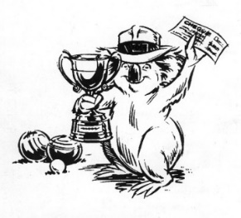
WINNERS ARE GRINNERS:
Congratulations to:
All members of our three premiership pennant sides
And also to:
Kylie Whitehead, Stephen Coulston.
Winners of the CLUB MIXED PAIRS CHAMPIONSHIP.
Lyn Winter, Elaine Gilby, Louise Farrar.
Winners of the LADIES’ CLUB TRIPLES CHAMPIOSHIP.
Lyn Winter, Margaret Bedford, Elaine Gilby.
Winners of the TWIN CITY PEST CONTROL LADIES’ TRIPLES.
Josh Rudd, Paul Davies, Ray Moon, Bob Breen.
Winners of the DUNSTAN MEMORIAL FOURS.
Margaret Bedford, Kylie Whitehead and Klive Liverton, Albert Critchlow.
Joint winners of the RADCLIFFE OPEN PAIRS.
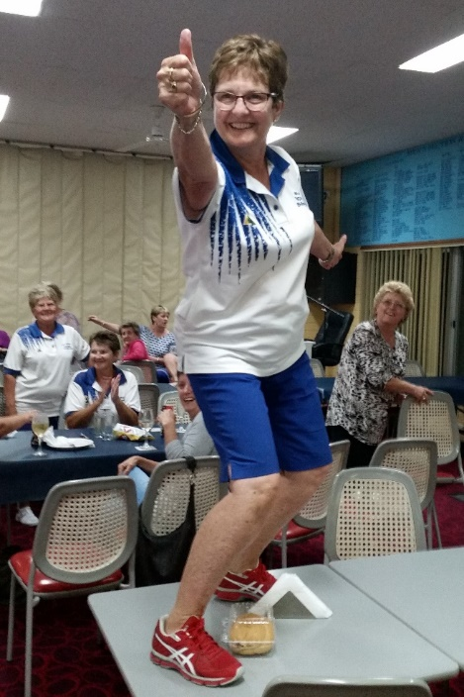
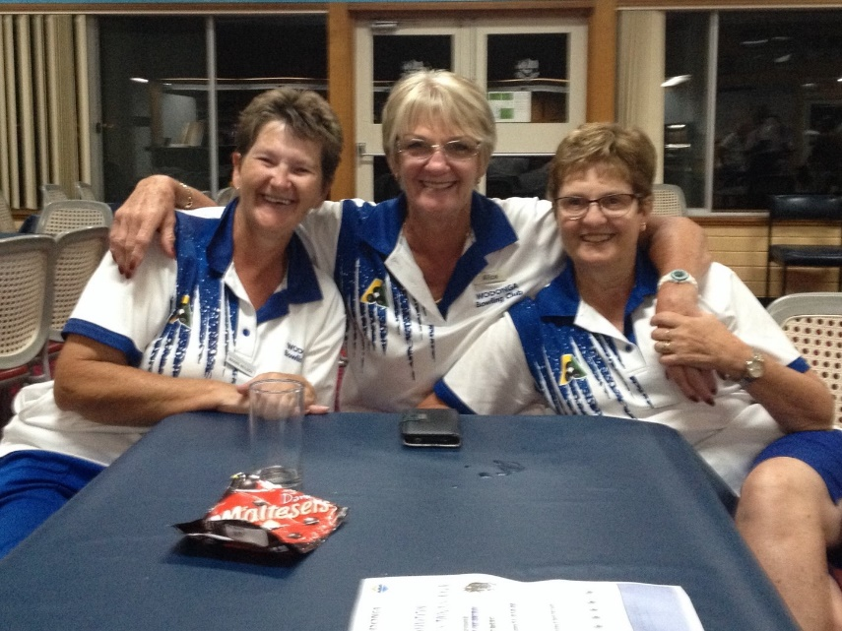
Some winners grin more than others!
OFFICE BEARERS 2017-18

President Ladies:
Pat Jackaman
Deputy President Ladies:
Dawn Fraser
President Men’s:
Vacant
Deputy President Men’s:
Vacant

Men’s Match Committee:
Ashley Bates
David King
Alec Green
Vacant
Vacant
Ladies’ Match Committee:
Louise Farrar
Leslie Duncan
Lyn Winter
Lyn Retallick
Vacant

Chairman:
David Broad
Director of Administration:
Maxine Neilson
Director of Finance:
John Harding
“General” Directors:
David Jackaman
Peter McLarty
Hellen Harrison
Vacant

Mid-Week Selection Committee:
Hellen Harrison
Pat Polly
Dianna Gardiner
Marlene Harris
Dawn Fraser
Weekend Selection Committee:
Vacant
Vacant
Vacant
Vacant
Vacant

Delegates to O&M Bowls:
Paul Davies
Jean Barber

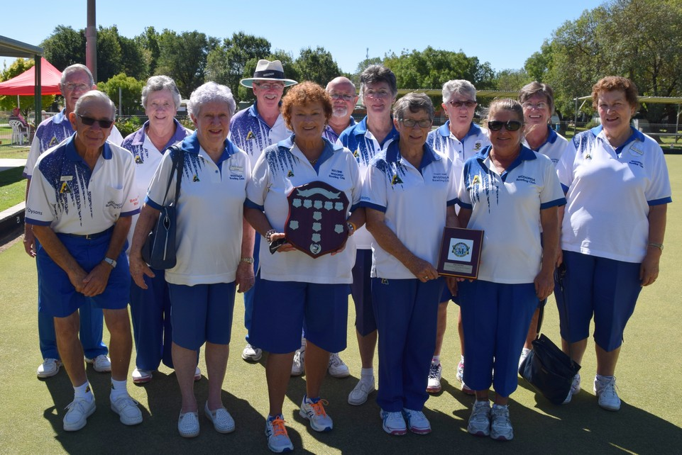
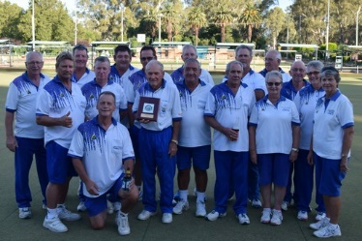
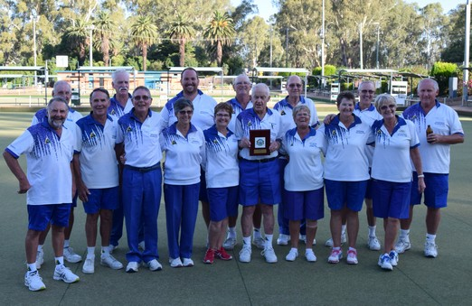

Generously sponsored by Radcliffe Funeral Services the Open Pairs event staged at Wodonga on 26th February attracted teams from Chiltern, Club Mulwala, Tawonga, Yackandandah, Kiewa and Rutherglen, along with a number of teams from the home club.
RADCLIFFE OPEN PAIRS PAIRS:

At the completion of the scheduled three games, the pairings of Marg Bedford and Kylie Whitehead and Albert Critchlow and Klive Liverton both compiled 47 points from three wins and shared first prize. Third prize went to Glen McGuire and Fred Baldock, fourth to Maxine Neilson and Bob Harbridge and fifth, on countback, to Brett Barton and Col Fitzmaurice. Best first game winners – Pam and Albert Dodman, second game – Gary Howlett and David King, third game – Lyn Retallick and Bob Ellwood tied with Liz and Ralph Coulston.
DUNSTAN FOURS MEMORIALFOURS

The 53rd Jack Dunstan Memorial Fours Tournament, sponsored by Westmont Aged Care and Alessi Mazda was conducted at Wodonga on Monday, 13th February. Twenty-eight teams from the North-East and Albury Districts entered and on the completion of four games of ten ends there were five 4-game winners necessitating play-offs to decide the place getters. Final results:1st – Bob Breen, Ray Moon, Paul Davies and Josh Rudd(s), 2nd – L. Quartermain, G. Brimblecombe, Greg McDonald and Ian Brimblecombe(s), Equal 3rd – John Howes, R. Bayliss, Paul Carey and Mason Bayliss(s) and Ian Baskett, M. Scown, Albert Critchlow and Klive Liverton(s), 5th – P. Smith, D. McNight, R. Mitchell and D. Crothers, 6th – David Christie, Chris Bird, David King and Max Scanlon(s).

There were four prizes for Best Game winners and the successful teams were as follows; - First game – Rick Robinson’s team from Beechworth, Second game – Peter Mongan and crew from Corryong, Third game – Ralph Fair’s composite side from Khancoban, Corryong and Wakool, Fourth game – Brian Walters team from Albury Commercial Club.

Many thanks for the generous sponsorship of Westmont Aged Care and Alessi Mazda event and thanks also to our “sponsor scouts” Brian Gilby and Bill Miller for their efforts in bringing sponsors “on board”. A pat on the back to the Match Committee for their efficient organisation of the day.

KYLIE’S SUCCESS

Over the past few months popular Wodonga member and regular Victorian representative Kylie Whitehead has been extremely busy. Currently, in the final stages of completing a physiotherapy degree with Charles Sturt University Kylie has her head down studying while on placement at Canberra Hospital where on completion will undertake a further placement at the Melbourne Children’s Hospital.

Although working hard on her studies this season Kylie has met with great success on the green winning three Club championships; Ladies’ Club Singles, Ladies’ Club Pairs and the Mixed Club Pairs; winning the O&M Ladies’ Singles, a member of the composite side that won the O&M Ladies’ Fours, won her way through to the final of the Victorian Women’s State Under 25 Singles and also had a very successful season with the Victorian State side.

However, at the time we go to print Kylie has had to raise her head from her studies to represent Victoria in the Australian Sides Championship being held at Lockley Bowling Club, South Australia and later in the month will go on to play in three events at the Victorian State Championships
STATE CHAMPIONSHIPS

Some of our members have indicated they are traveling to Bendigo to support Wodonga players competing in the Victorian State Championships to be held at the Bendigo East Bowling Club during the fortnight commencing Thursday 20th April and we urge as many other members as possible to make the trip to also lend their support.

On Tuesday 25th April at 9:30am the trio of Ray Moon, Paul Davies and Ashley Bates will play against West Coast (Warrnambool) in the Victorian Men’s State Triples Championship.

On Thursday 20th April Kylie Whitehead, at 9:30am, will play her first game against Jean Sprague from Rushworth in the Victorian Women’s State Singles Championship. The next day, Friday 21st April, she teams with Anne Miles, Shirley Hummel and Claire Sanders against a composite side from Central Goulburn (Murray) in the Victorian Women’s State Fours Championship again commencing at 9:30am.

To finish off the week Kylie will play Tiffany Brodie from Fitzroy in the Victorian Women’s State Under 25 Singles Championship at 4:00pm on Saturday 22nd April.

LADIES TRIPLES

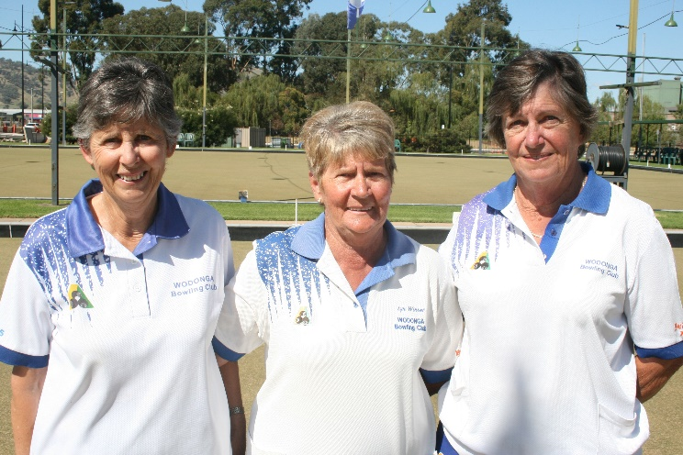
Last week, on a day and a green made for good bowls saw an extremely close encounter in the final of the Ladies’ Triples between Lyn Winter, Elaine Gilby, Louise Farrar and Cheryl Morgan, Lyn Retallick, Thelma White. Full of interest, the game went shot for shot throughout without either team able to forge a break.
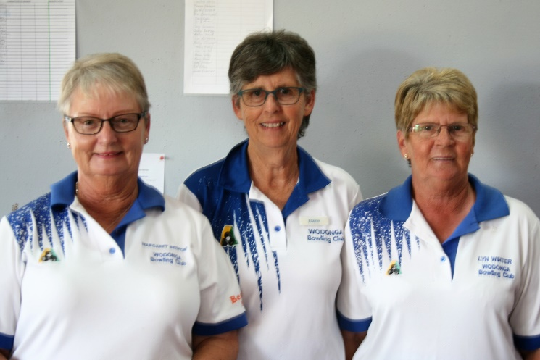
After some good bowling, going into the penultimate end Cheryl led by one shot. Under pressure Lyn, well supported by Elaine and Louise, won the end by four shots – the biggest winning margin of the match. Cheryl was now down by three with the pressure on her trio to pull off at least a three-shot win on the end to force a play-off. With her first two bowls Cheryl brought the margin back to one down on the match. Much to her disappointment Cheryl’s final bowl just – only just - pulled up slightly short given the championship to Lyn by the barest of margins.

THE BOWLS SHOW

Bowls will remain on free-to-air television in 2017, following the announcement that Bowls Australia and SBS have renewed their partnership with the extension of The Bowls Show for a second season and
will return to SBS on Sunday, May 14, in the new time-slot of 3.00pm nationwide.

The hour-long weekly program will again be shown across 20 weeks, up until October 22, due to a four-week hiatus from July 2-23 for SBS’s broadcast of the Tour de France.

Viewers will be treated to content from this year’s World Junior Championships, Australia v England Test Series, Australian Open and Australian Indoor Championships, as well as segments on coaching, development, high performance, club and social bowls and club profiles, in addition to feature interviews with stars of the sport.

INVITATION TRIPLES
LADIES TRIPLES
Last Friday the Club conducted the extremely successful Ladies Invitation 2 Bowl Triples Tournament which saw entries from 88 bowlers representing 15 clubs. Proudly sponsored by TWIN CITY PEST CONTROL (Maxine and Wally Bounader) nothing was left to chance in the organization of this event which lead to a great day. Visitors were amazed that Maxine was even able to order the great weather. More seriously, the visitors were particularly appreciative of the meal served at lunch and the effort put into the general presentation within the Club and the day.
After four games of ten ends there were three four game winners and after the counting of points the triple of Lyn Winter, Elaine Gilby and Margaret Bedford were declared winners on the day with Maxine Bounader, Alice Bounader and Joan Boyd coming second.
HOLIDAY BOWLS

Members who like to travel and would like to play bowls at interstate venues now have the opportunity to do so by traveling either North or South.
Entries are now being accepted for Australia’s biggest bowls festival, the Australian Open to be held on the Gold Coast, Queensland from June 10th to 23rd. All event details, entry forms can be found on the Australian Open website: http://australianopen.bowlsaustralia.com.au/
The Lawn Bowls Masters Games (age 35 or over) are being held at the Ulverstone Bowls Club and the Ulverstone Penguin Bowls Club, Penguin, Tasmania from October 21st to 28th. To receive further information or enter S download www.australianmastergames.com
NOTICE
The Club will be closed on:
Easter Sunday. 16th April
Easter Monday. 17th April
ANZAC Day. 25th April

COMMITTEE VACANCIES

Attendance at this year’s Annual General Meeting was down on the last couple of years and was disappointing as too was the number of committee positions not filled. All these unfilled positions are declared casual vacancies and under the Club Constitution and Club Regulations the Board of Management has the power to fill these casual vacancies.
The casual vacancy on the Board of Management will be filled under Constitution Rule 19 (e) which states: - If there are insufficient nominations received to fill all vacancies on the Board nominations can be called from the floor of the AGM and any remaining positions will be deemed casual vacancies under Rule 18.5. In turn Rule 18.5 Casual Vacancy (a) states: - In the event of a casual vacancy in the office of any Elected Director, the Board may appoint an appropriate Affiliated Member to the vacant office and the person so appointed may continue in office up to the end of the term of the Elected Director they are replacing.
Casual vacancies on committees can be filled under Regulation Part V – CLUB COMMITTEES (b) Which states: - The Board will determine how committee members will be elected and/or appointed from time to time.
At this stage, a number of members have put their hand up to fill some of these positions but not all of them. Consequently, the club is still looking for members to fill some of these vacant positions. At its next meeting, soon after Easter, the Board will determine who will fill the casual Board vacancy and other committee vacancies.

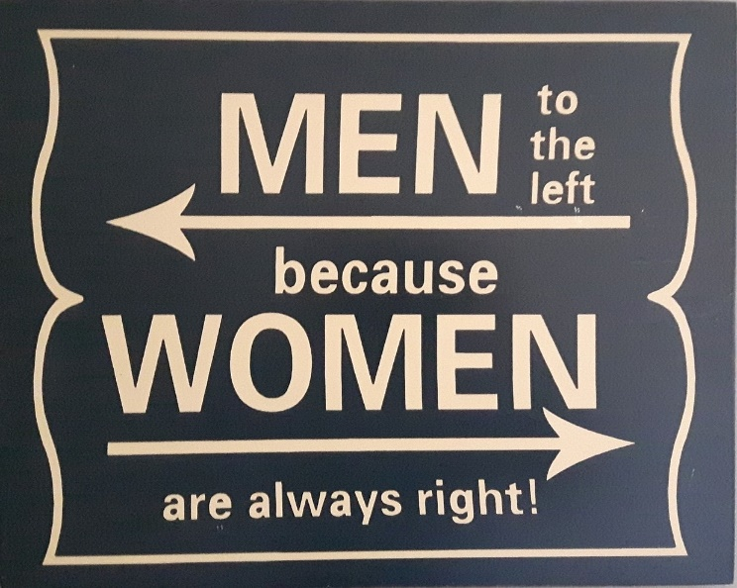

FUTURE EVENTS:
Entries are still open for the Good Friday 'OPEN Pairs' - 12.30pm start
and
the Easter Saturday 'OPEN Pairs' 9.30am start.
Entry sheets on the “entry desk”.

Don’t forget Sat 22 April ’ALBURY-WODONGA
RV WORLD' OPEN TRIPLES. Another exciting event
and
Sat 20 & Sun 21 May is the Commercial Club Classic (formally Liqourland).
Entry sheets for the above events are on the club Notice Boards

Every Tuesday is Ladies’ Social
Every Wednesday is Men’s Social
Each Saturday other than those listed will be Jackpot Pairs
NOTICE
WEDNESDAY 19TH APRIL
4:15pm
Meeting to gauge feelings about Weekend Pennant Team Nominations and interest in the Weekend Selection Committee.
Immediately after Bowls!
Everyone please remain for this important meeting.

DAVID BROAD ASHLEY BATES

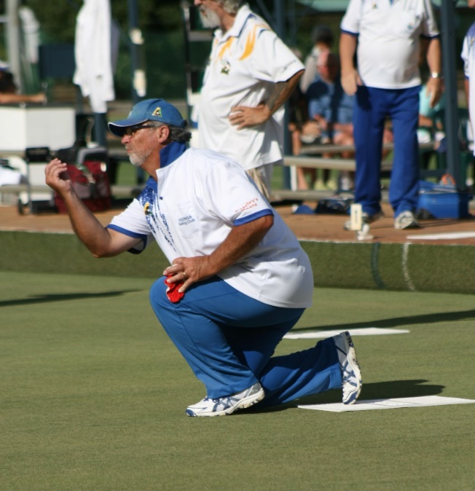
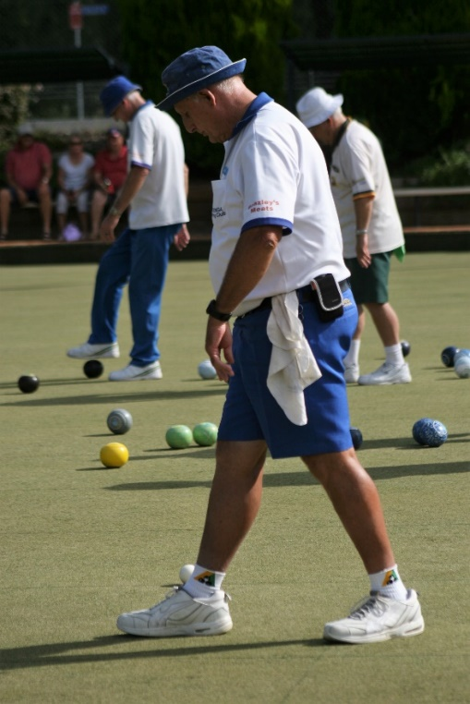
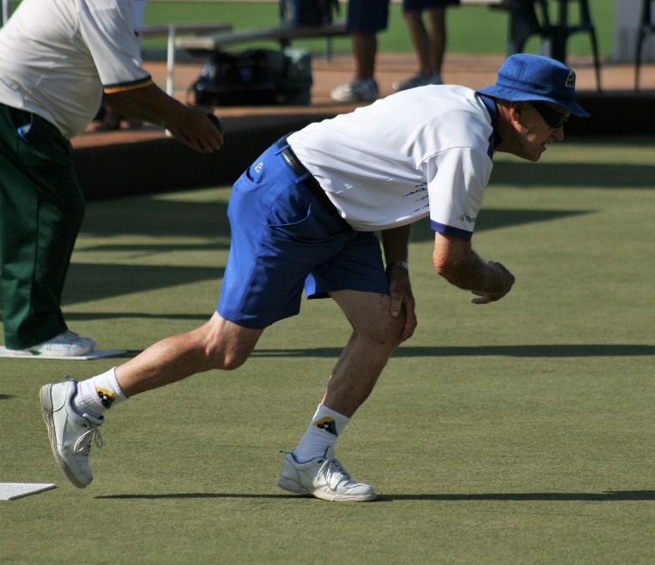
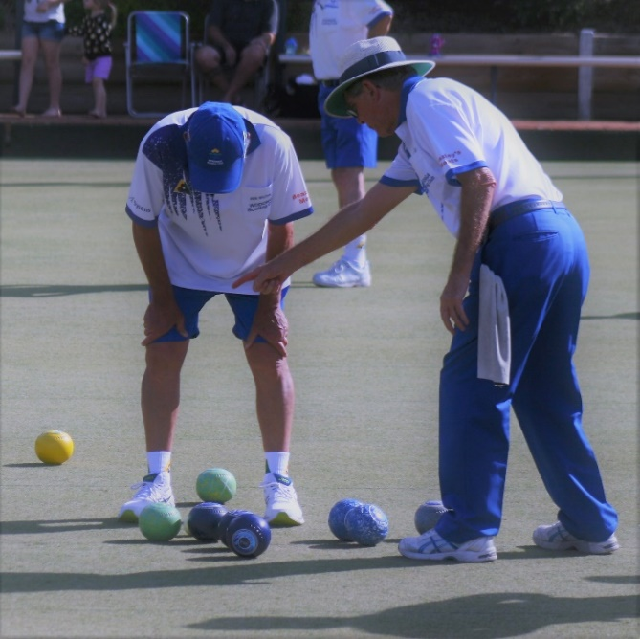
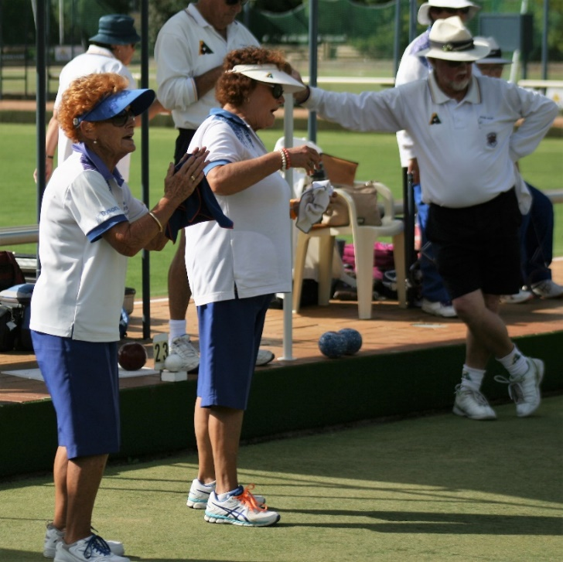
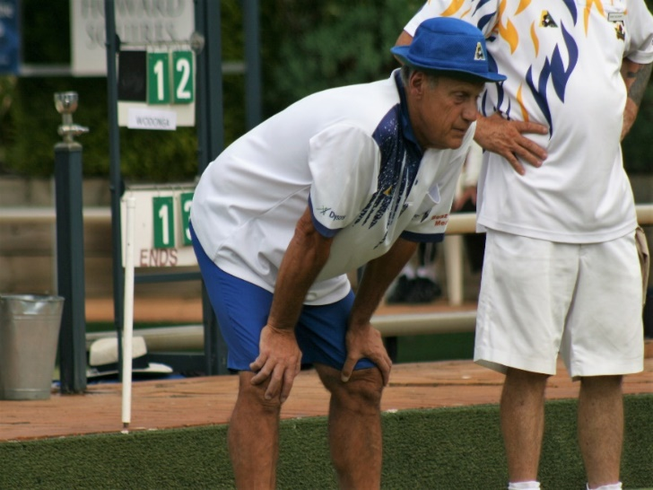
LADIES TRIPLES

