Dunstan’s Day Men’s Fours
Proudly sponsored by SS&A Albury
Monday 9th of March 2020

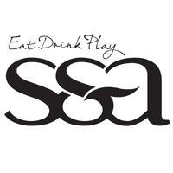
9:30am Start
Total Prize Money: $ 2120
4 games of 10 ends
(4 game winners playoff)
Entry Fee: $100

1st: $760 2nd: $360 3rd: $240 4th: $160 5th: $100 6th: $100
Best each game winner: 4 x $100

Entries to: Wodonga Bowling Club (02) 6024 1554
Or email: wodongabc@gmail.com

