NEWSLETTER

ISSUE 6 – MARCH SEASON 2016-17

WEBSITE – www.wodonga.bowls.com.au

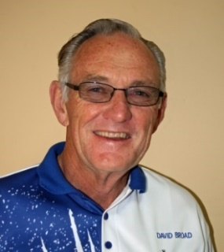
FROM CHAIRMAN DAVID:

ANNUAL GENERAL MEETING - THURSDAY 30th MARCH:
Members will now have received notice of the Annual General Meeting. As I stated last month, there is an urgent need for all members to seriously consider their ability and willingness to help sustain the future of the Club first as a business, and then as a Bowling Club. If we are not a viable business, then the Bowling Club sooner or later will fold. A small band of members keep the Club afloat, but the majority do not contribute and must reconsider how they can help either physically or financially, but everyone has a responsibility if they wish to continue playing bowls at our magnificent Club, where much has been achieved in recent years, but many challenges remain.

VOLUNTEER MAINTENANCE OF OUR GREENS:
As we all know DJ is in hospital and we wish him a speedy recovery. In the meantime, under the stewardship of Facilities& Greens Director, David Jackaman, the efforts of Tony Smedley, Rob Taylor, John Boyd and Paul Smythe must be applauded by us all. They are maintaining our greens magnificently without incurring additional cost, which shows great club spirit by all those involved. Likewise, our hard-working Hovel Street frontage landscape gardener, Liz Coulston, is also in hospital, however, her loyal helpers in husband Ralph and the reliable Barrie Nash are keeping things up to scratch. We also wish Liz a speedy recovery. It was also great to see Allan Bounader helping the Ladies in the Kitchen during their tournament last Friday.

NEW FENCE AT REAR OF CLUB ON NEW HAVELOCK ST. FRONTAGE:
Well in a little over 24 hours our new fence appeared and by most reports everyone thinks it looks both smart and well positioned. Thanks, go to Ty Crichton of Crito’s Construction & Rigging for the very neat and prompt attention to our needs as the new road rapidly nears completion, and to John Derrig and John Evans for assisting me with the severe hedge trimming that was required on the Thursday so contractors could start work on the Friday. Bill Miller’s ute made the unloading job very easy, and the following weekend it’s appropriate to thank John Harding for spraying all the weeds in the unfinished/untidy car park.

CAR PARK, FENCE, COUNCIL AND CONTRACTORS “EXCELL GRAY BRUNI”:
Firstly, as previously advised Bill Fraser and myself met with the Council hierarchy on the 24th January, and again on the 15th February. I also meet the Chief Engineer/ Deputy CEO Leon Schultz onsite at 7.30 am on 24th February. This is a summary of undertakings given, although at the time of writing a confirming Email had not been received: -
- Council will only pay 50 % on the fence construction or $5,911.50 exGST.
- A Council specification drawn up some months ago, by the Council Project Engineer for completion of the car park was far above our needs or ability to pay at an estimated $60,000. Although appreciated, it was eventually quoted on to a slightly less standard, without kerbing and traffic islands, by Excell Gray Bruni at about $37,000.
- Following the latest meetings with Council and Leon Shultz, and after further negotiations with the contractor, this has been squeezed down to $29,000 to which the Council will contribute $5,000, leaving a balance of $24,000 to be met by the Club. The work would involve excavation of the currently unsealed area where dangerous trees were removed and the ground consolidated by a working bee, back filling with high quality crushed rock, patching of our section of the old fire brigade track, followed up with a 10mm bitumen seal over the entire 980 square metre area, and the marking out of parking bays. This would be financed by drawing back against the current loan if agreed to by the Board. I personally think it’s now or never and we must proceed. The loan balance at present stands at $60,000 after appearing in last year’s balance sheet at $75,000.
- Further to this a drainage problem for the Club caused by the height of the new footpath is to be resolved with a variation to the road contract, and a similar variation will see our rear fence between the works shed and the new road, replaced with higher fencing that matches the new fence behind the water tank. Again, this is being done because of the dramatic rise in the footpath levels to Osburn Street.

BUSINESS HOUSE, NEIGHBOURHOOD, TWILIGHT BOWLS:
Another successful four weeks concluded on Thursday the 23rd February with 20 teams competing, and my thanks go to Brian Gilby, David King, Rob Taylor, Rick Gillman and those associated with feeding the multitude, for their efforts in ensuring the Club presented well to our visitors. Also, we must thank all those new and past participants who made each night such a success, and trust they had a great time and will return. All of them have been invited to Saturday Jack Pot pairs in the winter, and a Sunday morning competition for members and guests is being fired up from the 5th March.

CATERING AND BISTRO:
Members will know by now that TIM HOWE is taking over the kitchen with the obligation to cater for all Club events at an affordable cost, while hopefully running a fully commercial and profitable Bistro on Friday and Saturday nights, which members need to support at every opportunity. Tim seems much more professional than our pre-Christmas kitchen operators, is well organised, and has a “Mission to combine great tasting with excellent customer service”. Tim is available to cater for functions of all types and size, and we wish him the very best in his endeavours. The success of this venture is extremely important to the Club. First night was the 24th February and Christa and I, along with over 30 others, had a very enjoyable meal and social night out. As Tim gets a better feel for and routine in his new kitchen, “good will only get better”. Table service was delivered efficiently and with good humour.
NOTE: An evening meal is definitely available on Sat. 18th March prior to the Eddie Daniels “Elvis/Orbison” concert, which members are also urged to support.

REGULAR WORKING BEE:
This will not be scheduled for March, as we have plenty on our plate while DJ is away, but if you can help in any way please make an offer. Also, every member who cares for their Club should be keeping an eye for anything out of place in the Clubhouse, around the greens, or in the toilets, which they can easily rectify. Everyone is requested to pick up pieces of paper or food and pull out weeds that will help enhance the Club image with visitors. It is no great chore, and we all need to show pride in our Club’s presentation!

David
WINNERS ARE GRINNERS:

Congratulations to:
Kylie Whitehead and Margo Howe.
Winners of the LADIES’ CLUB PAIRS CHAMPIONSHIP.
Bill Luty and Fred Baldock.
Winners of the MEN’S CLUB PAIRS CHAMPIONSHIP.

MARCH DATES TO MARK IN YOUR DIARY:

Sun 5 Men’s Handicap Singles Rnds 1 & 2
Mon 6 Ladies’ Information Meeting
Thur 9 Ladies’ Club Triples Rnd 1
LADIES MEETING
Monday 6th
March.
1:00pm

Sat 11 Jackpot Pairs
Sun 12 Men’s Handicap Singles Rnd 3
Mon 13 Dunstan Day Men’s Fours
Thu 16 Wodonga Over60 Men’s Fours
Fri 17 Ladies’ Club Triples Rnd 2
Sun 19 Men’s Handicap Singles Rnd 4
Thu 23 Ladies Club Triples Rnd 3
Sun 26 Radcliff Mixed Pairs
Tue 28 Midweek Pennant Grand Finals
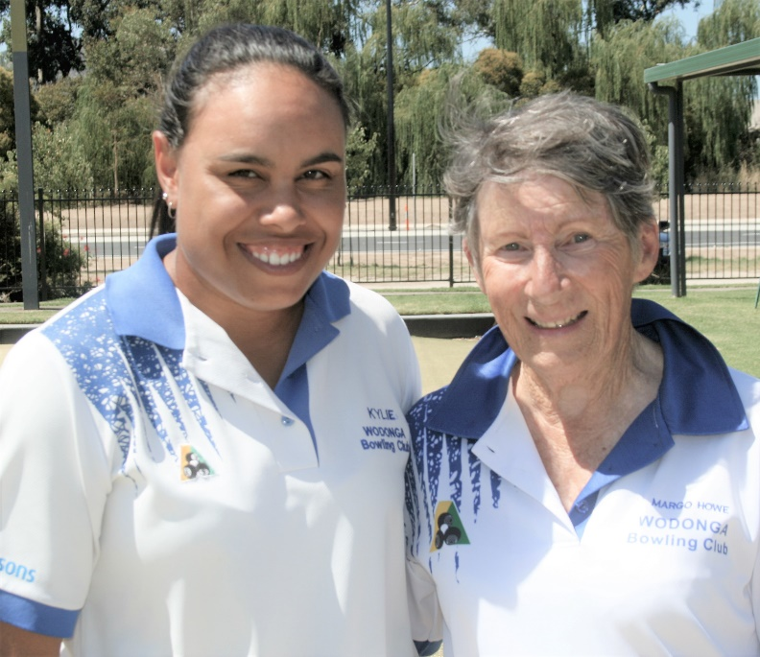
CLUB PAIRS CHAMPIONS:
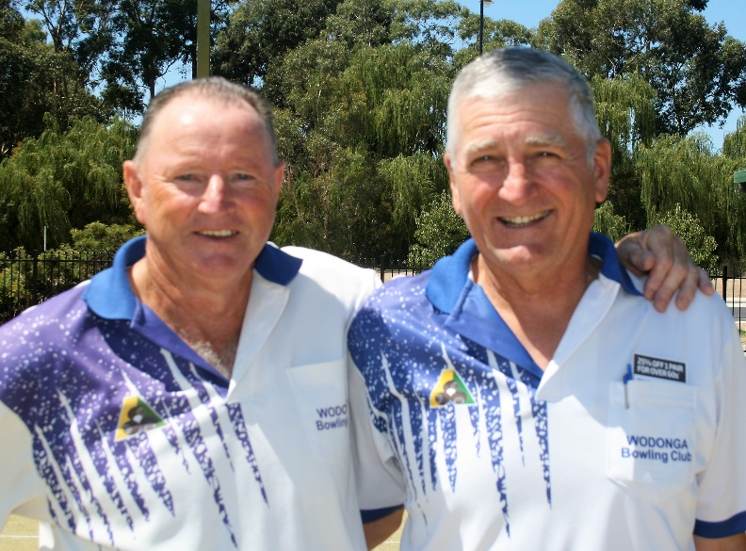
The club Men’s and Ladies’ Pairs Championship Finals were conducted on Sunday, 26th Feb. with Fred Baldock and Bill Luty taking out the Men’s’ event for the second successive year with a very comfortable victory over Rob Taylor and Tony Smedley while Margot Howe and Kylie Whitehead proved too good for Elaine Gilby and Lyn Winter.

The scores in both games did not reflect the high standard of bowling which maintained the interest of all spectators right throughout both games. All eight players are to be congratulated on their performance with Kylie in particular playing some superb bowls.

UNIFORMS:
The Club Uniform Sub-committee is currently waiting on samples of material and design for new uniforms and consequently at this stage has not made a recommendation to the Board for any change to the current Club uniforms.

While some members feel strongly, and have voiced their opinion, that the shirt should be “modernized” there are others who are happy with what we have and see no reason for change. On the other hand, it would appear that the silent majority of members are not particularly interested in the subject.

If a change to the uniform design is recommended, we understand the recommended change will not be dramatic. Nonetheless, if a change is accepted by members it will require new shirts for all.

MEDLEY FOURS:
The Wodonga Ladies conducted their Annual Medley Fours Tournament, sponsored by McHargs Solicitors and Conway Funeral Homes, on 24th February with 88 players from clubs as far afield as Lockhart taking part. With good numbers, good weather, good greens and good fellowship the Club was extremely pleased with the day and once again many thanks to the generous sponsors.

At the end of the day, the Corowa Services team of M.Welfare, A.Muir, R.Baddeley and S.Swift took out first prize on countback from the Wodonga side of Margaret Cameron, Marg Hickey, Marlene Ellis and Cheryl Morgan with Thelma White, Pat Polley, Dawn Fraser and Lesley Duncan, also from Wodonga, in third place. Prize for Best Last Game Winner went to B.Reichman, J.Douglas, J.Hughes and Jan Fisher of Rutherglen.

VALE
SEBIRE Philip (Bottles). It is with deep sadness the Board of Management and members mourn the loss of popular and highly respected fellow bowler. Condolences are extended to Philip’s family.

COMMUNICATION:

From time to time members of the Board of Management receive complaints from members who claim “they don’t know what’s going on at the Club”. On the other hand, some members have confessed they couldn’t be bothered looking at the notice boards because “there is too much junk on display” nor do they bother to read the Club’s Newsletter.

The Board of Management has long acknowledged that communication in a club the size of ours is always going to be difficult hence their strong support for the monthly Newsletter where all members (if they so desire) can have a say and where Chairman David each month publishes activities relating to Club business as well as expressing his views on pertinent issues. We remind all members items/articles of interest – no matter how controversial - are welcome for publication in the Newsletter.

The Club now also has a “FACEBOOK” page and all the latest Club information will appear on that page. The Board also encourages members who have a computer to visit the Club’s Website -www.wodonga.bowls.com.au - and catch up on the latest. They further remind members that under the Government Act covering incorporated bodies, on request, all members of the Club are entitled to view a copy of minutes of all Board Meetings.

ANNUAL GENERAL MEETING:

As mentioned in Chairman David’s report the club’s Annual General Meeting will be held on Thursday 30th March. There is no indication from current office bearers who may or may not be seeking re-election nor indication from any other member who may be thinking of standing for a position but as all positions must be filled it is fair to say all positions are open.

Once again, members are requested to take this matter very seriously and are reminded (it cannot be over stressed) the importance of the need for careful management of the club at this stage of its development and therefore give a great deal of consideration to the nomination of potential office bearers.

Positions to be filled are as follows:
Chairman of the Board: Director of Administration:
Director of Finance: Four (4) “General” Directors:
President Ladies’: Deputy President Ladies’:
President Men’s: Deputy President Men’s:
Mid-Week Selection Committee: Five (5) (Nonspecific gender):
Weekend Selection Committee: Five (5) (Nonspecific gender):
Match Committee: ten (10) – five (5) ladies and five (5) men:
Delegates: two (2) – one (1) lady and one (1) man:

It should be noted that the regulation regarding a selection committee of ten, five ladies and five men, has recently been altered to now having two selection committees – one mid-week selection committee of five members and one weekend selection committee of five members. There is no stipulation of gender on either committee nor is there any rule to prevent a member serving on both committees.
BOWLS AUSTRALIA SURVEY:
Bowls Australia is seeking the input of the entire bowls community to help shape the strategic direction of the sport over the next five years and is embarking on a process of developing the Bowls in Australia 2017-2022 strategic plan.

The plan will guide the growth and development of all aspects of the sport nationally, over the coming five years and Bowls Australia is calling on members and participants to voice their opinion on the opportunities, strengths, barriers and initiatives that the sport may face over the next five-year period, through a simple six question online
survey.
in order to gain meaningful insights from a cross-section of all stakeholders, all past and present bowlers, participants and administrators are encouraged to fill out the very quick and simple online survey, which will be open until the close of business on Monday, March 13, 2017.
To view the e-survey: https://www.surveymonkey.com/r/63B82QF

FROM THE PAST:
FIRST LIFE MEMBER:
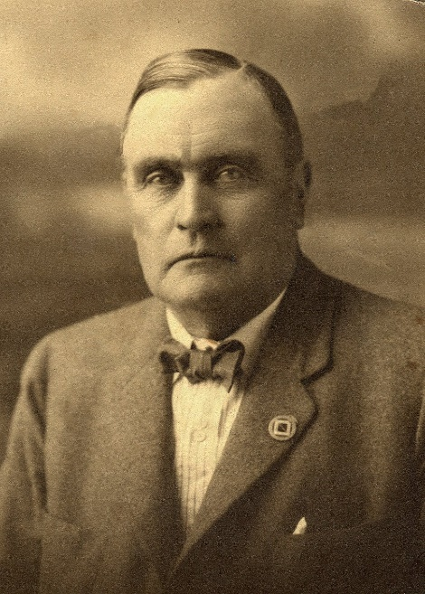
Currently, Wodonga Bowling Club has only one life member, John Drummond, who was awarded this prestigious honour last season. But since the Club’s formation in 1925 quite a few members have been awarded life membership in recognition of their services, however, unfortunately, apart from John, there is no indication in club records of who in the past were the recipients of this honour. We do know, however, the first person to be awarded Wodonga Bowling Club life membership was Percy Herbert Lingford in 1926.
Appointed to the position of Wodonga’s Shire Engineer in 1916, because of his position and personality by the 1920s Lingford was undoubtedly Wodonga’s most influential citizen. Involved in most community activities, president of the racing club, sitting on the bench as a JP he was highly respected and also very persuasive. Conscious of the need for the town to be progressive Lingford, although enjoying bowls but not strongly committed to the game as some, saw the establishment of a bowling club as a positive step towards making life “brighter and better for the community” and believed a bowling club would enhance the town in general.
Lingford was elected first president when Club formally constituted 9th September 1925. He arranged with council for the rental of land where clubhouse and greens now stand for the sum of one shilling per annum. He prepared plans, set levels etc. and supervised the construction of the Wodonga greens and building of a pavilion by voluntary labour.
Unfortunately, Lingford tendered his resignation as president of Wodonga Bowling Club at the first AGM held on 14TH September 1926 explaining he had accepted a position with Rutherglen Shire Council and would be moving to reside in that town. All in attendance expressed great regret at Percy’s departure and later in the meeting he was unanimously elected the club’s first life member for his great service to the club in the relatively short time it had been in existence. The club also honoured him by requesting he perform the inaugural opening of the greens on Saturday 23rd October 1926.
The opening was a grand event with many dignitaries, visitors, members, clergymen and local citizens in attendance. There was no shortage of orators. Lingford then presented a flag in the Club’s colours of navy blue with a white border and white W.B.C. in the centre to the secretary and asked him to hoist it. The secretary in turn presented Lingford with a club life membership badge in recognition of his services to the club.
Percy Lingford’s name is recorded on the Club’s honour board as the Club’s first secretary. He never held this position but was the Club’s first president (albeit for only short time) and certainly the Club’s first life member. Percy died in 1932 at the age of 70 and was buried in Rutherglen. His youngest son, also Percy Herbert (called Bert), was killed during the First World War and his name is on the Wodonga War Memorial Monument.

18th March:
“ONE MAGIC NIGHT”
2½hrs of entertainment
7.30pm
SOCIAL BOWLS IS BACK !!!
Sunday BAREFOOT Bowls
Starting March 5th and running through the whole bowls season

9:30am START
Everyone Welcome
Prizes for Winners & Runner-up
Entry Fee $10.00 per player
( includes BBQ snacks )
open draw / pick a card
2 x games of 2: 4: 2 pairs
Place your name on the list provided
or email to
wbc.match @ dodo.com
to register your name weekly

MARCH

MON | TUES | WED | THURS | FRI | SAT | SUN
 |  | 1  Men’s Pairs  2:4:2 | 2  Ladies’ Social | 3  Happy Hour  &  Raffles | 4  Weekend  Pennant | 5  Men’s  Handicap  Singles  Rnds 1 & 2
6  Ladies’  Meeting  Greens  Closed | 7  Mid-Week  Pennant  Ladies  Social | 8  Men’s Pairs  2:4:2 | 9  Ladies’  Club Triples  Rnd. 1  Ladies  Social | 10  Happy Hour  &  Raffles | 11  Jackpot  Pairs | 12  Men’s  Handicap  Singles  Rnd 3
13  Dunstan Day  Men’s Fours | 14  Mid-Week  Pennant  Finals | 15  Men’s Pairs  2:4:2 | 16  Over 60 Men’s Fours  Tournament | 17  Ladies’  Club Triples  Rnd. 2  Happy Hour  &  Raffles | 18  Weekend  Pennant  Elimination  Finals | 19  Men’s  Handicap  Singles  Rnd 4
20  Greens  Closed | 21  Mid-Week  Pennant | 22  Men’s Pairs  2:4:2 | 23  Ladies’  Club Triples  Rnd. 3  Ladies’  Social | 24  Happy Hour  &  Raffles | 25  Weekend  Pennant  Prelim.  Finals | 26  Radcliff  Open Pairs
27  Greens  Closed | 28  Mid-Week  Pennant  Grand Finals | 29  Men’s Pairs  2:4:2 | 30  Ladies’  Social | 31

